Siobhan’s really helpful article for families:
https://medium.com/@siobhancurrie/how-to-respond-to-the-coronavirus-when-it-impacts-your-family-ceba63cd4235
Coronavirus social story:
https://www.flipsnack.com/KeshetChicago/coronavirus-social-story/full-view.html
Talking to children about COVID-19:
https://childmind.org/article/talking-to-kids-about-the-coronavirus/
Talking to teens about COVID-19:
https://www.health.harvard.edu/blog/how-to-talk-to-teens-about-the-new-coronavirus-2020031419192

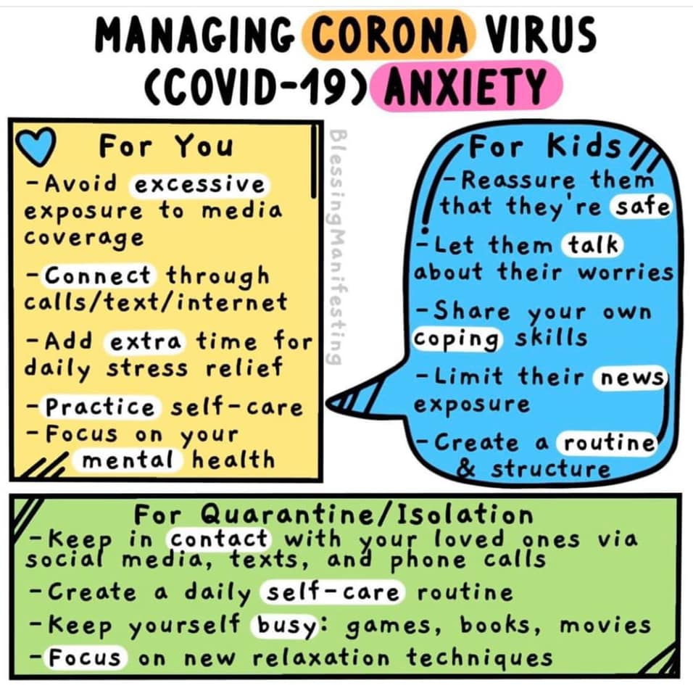
Coronavirus (taken from Mum in the Moment Facebook Page)
It’s all the children are talking about in the schools I work in. They need some help.
Some of our children are extremely anxious. For those of you who have children who are a little extra sensitive, anxious or OCD, it can make their struggles so much worse.
At times like these, we need to be positive role models for our children. We need to be careful of what we say in front of their little ears.
Be mindful not to make jokes about coronavirus in front of your children. A joke that seems funny to you (or your children) can be very real for others. Please remind your children to be kind with their words too.
- Kindness is contagious... but something worth spreading. Pass the kindness on at this time of unease and uncertainty.
To help calm the chaos, I have put together all the best links and videos I’ve found that can help you to explain Coronavirus to children, teens and young adults.
Before talking to your child about the coronavirus outbreak please try and reduce your own fear and anxiety around it. They need to see and hear your calm.
- 7 Breathing exercises to help children feel calm
https://muminthemoment.com/breathing-exercises-techniques-…/
- Child Mind: Talking to kids about coronavirus
https://childmind.org/…/talking-to-kids-about-the-coronavi…/
- Just For Kids: A Comic Exploring The New Coronavirus
https://www.npr.org/…/just-for-kids-a-comic-exploring-the-n…
- 5 Ways to Help Teens Manage Anxiety About the Coronavirus
https://www.nytimes.com/…/coronavirus-teenagers-anxiety.html
- Experts offers parents advice for talking to their children about the COVID-19 outbreak.
https://www.huffpost.com/…/coronavirus-how-to-talk-to-kids-…
- How to Explain the Coronavirus to Kids with Anxiety or OCD
https://www.anxioustoddlers.com/how-to-explain-the-coronav…/
- Coronavirus Talking Points for Parents & Teachers with the Whole-Brain Child Approach
https://www.tinabryson.com/…/coronavirus-talking-points-for…
- You tube video explaining coronavirus (suitable for children)
https://youtu.be/C3BZnldL66E
- For the grown ups
https://www.mind.org.uk/in…/coronavirus-and-your-wellbeing/…
Let's all try to respond in the calmest, wisest and kindest way we can
Image credit: Blessing Manifesting

