

Relationships and Behaviour Regulation Policy

Date Policy agreed: | May 2025
Date of next review: | May 2026
Head Teacher signature
Chair of Governors Signature

Contents

Statement of intent
- Legal Framework
- Roles and responsibilities
- Definitions
- Staff induction, development and support
- Managing Behaviour
- Prevention strategies and sanctions for managing behaviour
- Sexual abuse and discrimination
- Smoking and controlled substances
- Prohibited items, searching pupils and confiscation
- Effective classroom management
- Behaviour outside of school premises
- Data collection and behaviour evaluation
- Monitoring and review

Appendices:

  - Appendix 1 – Managing incidents and agreed sanctions for unacceptable behaviour flowchart
  - Appendix 2 – Managing incidents and agreed sanctions for unacceptable behaviour flowchart for children
  - Appendix 3- Behaviour scripts for learning time
  - Appendix 4- Behaviour scripts for playtime and dinner time
  - Appendix 5 – CPOMS Behaviour Log template
  - Appendix 6- Reflection sheets

Statement of Intent
Our vision at Pierrepont Gamston states:
We are a school where children love to learn and learn to love each and every day. A community where all children flourish and discover who God created them to be.
This is lived out through by our 4 whole school values of Radiate Love, Spark Wonder, Embrace Wisdom and Cultivate Hope.
This policy centres around the habits that children develop through our Radiate Love value to:

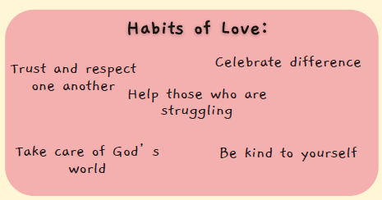
Just as I have loved you, you also are to love one another.
John 13:34
There are three key ideas at the heart of our relationship-based approach to inclusion philosophy:
1. Unmet Need: Behaviour communicates an unmet need. Therefore, to change behaviour, we must respond to the unmet need.
2. Individual Influences: Children’s behaviour cannot be fully understood in isolation, without considering their individual influences.
3. Relationship-based, restorative approaches offer an evidence-based alternative to zero-tolerance behaviour management systems.
The school acknowledges that behaviour can sometimes be the result of educational needs, mental health issues, or other needs or vulnerabilities, and will address these needs via an individualised graduated response.
To help reduce the likelihood of behavioural issues related to social, emotional or mental health (SEMH), the school aims to create a safe and calm environment in which positive mental health and wellbeing are promoted and pupils are taught to be resilient. The school aims to promote resilience as part of a whole-school approach using the following methods:
- Culture, ethos and environment – the health and wellbeing of pupils and staff is promoted through the informal curriculum, including leadership practice, policies, values and attitudes, alongside the social and physical environment.
- Teaching – the curriculum is used to develop pupils’ knowledge about health and wellbeing.
- Community engagement – the school proactively engages with parents, outside agencies and the wider community to promote consistent support for pupils’ health and wellbeing.

All staff will be made aware of how potentially traumatic adverse childhood experiences (ACEs), including abuse and neglect, can impact on a pupil’s mental health, behaviour, and education. Where vulnerable pupils or groups are identified, provision will be made to support and promote their positive mental health. The school’s Social, Emotional and Mental Health (SEMH) Policy outlines the specific procedures that will be used to assess these pupils for any SEMH-related difficulties that could affect their behaviour.

We have 3 whole school rules to promote good behaviour:

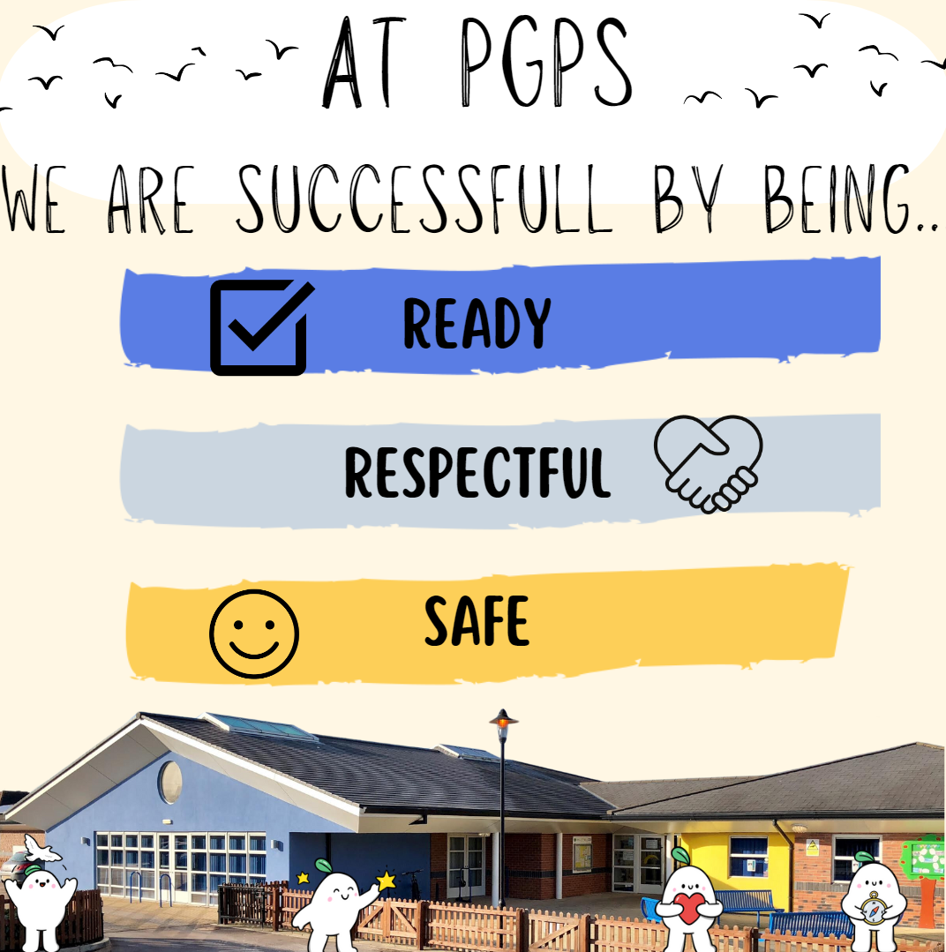
Details of our approach:
Please refer to ‘Understanding Behaviour in Schools: A relationship-based approach to inclusion’ (NCC July 2022). We use a strengths-based approach include relationship-based practice and restorative practice.
This is not really about what we do but how we do it, everything we do starts with relationships – building, maintaining and repairing relationships.

Key models and approaches include:
• Responding in the Moment (Notts EPS 2020)
• Emotion Coaching
• The Restorative Classroom: Using restorative approaches to foster effective learning by Belinda Hopkins (2011)
• Maslow’s Hierarchy of Need (1954)
• The whole school approach to behaviour regulation is in line with the Education Endowment Foundation recommendations on Improving Behaviour in Schools (2019).

Legal framework
This policy was based on guidance provided by the local authority following consultation with members of staff, representatives from the governing body, parents and carers and pupils.
This policy has due regard to all relevant legislation and statutory guidance including, but not limited to, the following:
- Education Act 1996
- Education Act 2002
- Education and Inspections Act 2006
- Health Act 2006
- The School Information (England) Regulations 2008
- Equality Act 2010
- Voyeurism (Offences) Act 2019
- DfE (2013) ‘Use of reasonable force’
- DfE (2015) ‘Special educational needs and disability code of practice: 0 to 25 years’
- DfE (2018) ‘Mental health and behaviour in schools’
- DfE (2021) ‘Sexual violence and sexual harassment between children in schools and colleges’
- DfE (2022) ‘Behaviour in schools: Advice for headteachers and school staff’
- DfE (2022) ‘Keeping children safe in education 2022’
- DfE (2022) ‘Searching, Screening and Confiscation: Advice for schools’
- DfE (2022) ‘Suspension and Permanent Exclusion from maintained schools, academies and pupil referral units in England, including pupil movement’
This policy operates in conjunction with the following school policies:
- Complaints Procedures Policy
- Special Educational Needs and Disabilities (SEND) Policy
- Child on Child Abuse Policy
- Child Protection and Safeguarding Policy
- Smoke-Free Policy
- Drug and Alcohol Policy
- Anti-bullying Policy
- E-Safety Policy
- SEMH Policy
- Physical Intervention Policy

Roles and responsibilities
This policy is for all staff, pupils/students, parents and carers, governors, visitors and partner agencies working within the school and provides guidelines and procedures as to how our school supports and responds to behaviour and emotional distress.
The governing body has overall responsibility for:
- Making a statement of behaviour principles, and providing guidance for the headteacher on promoting good behaviour where appropriate.
- Ensuring that this policy, as written, does not discriminate on any grounds, including, but not limited to, age, disability, gender reassignment, gender identity, marriage and civil partnership, race, religion or belief, sex and sexual orientation.
- Promoting a whole-school culture where calm, dignity and structure encompass every space and activity.
- Handling complaints regarding this policy, as outlined in the school’s Complaints Procedures Policy.
- Ensuring this policy is published on the school website.
The head teacher is responsible for:
- The monitoring and implementation of this policy and of the behaviour procedures at the school. This includes the policy’s effectiveness in addressing any social, emotional and mental health (SEMH) related drivers of poor behaviour.
- Acting in accordance with the statement of behaviour principles made by the governing board, and having any regard to guidance provided by the governing board on promoting good behaviour.
- Establishing high expectations of pupils’ conduct and behaviour, and implementing measures to achieve this. Ensuring that children learn to love and treat each other with respect.
- Determining the school rules and any disciplinary sanctions for breaking the rules.
- The day-to-day implementation of this policy.
- Publishing this policy in writing to staff, parents and pupils at least once a year.
- Reporting to the governing board on the implementation of this policy, including its effectiveness in addressing any SEMH-related issues that could be driving disruptive behaviour.
- Supporting Staff well-being and reflection – in recognition of the link between emotions and learning (EEF) and prioritising the adults’ emotional needs (Anna Freud Centre).
The deputy and assistant heads are responsible for:
- Supporting staff with the implementation of this policy and ensuring our whole school values are upheld across their pod
- Meeting with parents alongside staff where children are struggling to follow the behaviour policy
- Writing risk assessments alongside other senior leaders – involving children in the creation of these
- Monitoring behaviour incidents and reporting back to SLT each half term
- Ensuring head teacher is alerted to any level 3 or 4 behaviour incidents
- Ensuring head teacher is aware of staff well-being when dealing with pupils behaviour, Referring any concerns regarding support required. Reminding staff that collaboration is key “Nobody can do this on their own”

The mental health lead is responsible for:
- Overseeing the whole-school approach to mental health, including how this is reflected in this policy, how staff are supported with managing pupils with SEMH-related behavioural difficulties, and how the school engages pupils and parents with regards to the behaviour of pupils with SEMH difficulties.
- Supporting behaviour management in line with the SEMH Policy- recognising that this approach will have a positive approach on the emotional health and wellbeing and learning
The SENCO is responsible for:
- Collaborating with the governing body, headteacher and the mental health lead to determine the strategic development of behaviour and SEMH policies and provisions in the school.
- Undertaking day-to-day responsibilities for the successful operation of the behaviour and SEMH policies to support pupils with SEND, in line with the school’s Special Educational Needs and Disabilities (SEND) Policy.
- Supporting teachers in the further assessment of a pupil’s strengths and areas for improvement and advising on the effective implementation of support.
Teaching staff are responsible for:
- Planning and reviewing support for pupils with behavioural difficulties in collaboration with parents, the SENCO and, where appropriate, the pupils themselves.
- Aiming to teach all pupils the full curriculum, whatever their prior attainment.
- Planning lessons to address potential areas of difficulty to ensure that there are no barriers to every pupil achieving their full potential to flourish
- Teaching and modelling expected behaviour and positive relationships, demonstrating good habits.
- Being responsible and accountable for the progress and development of the pupils in their class.
- Following the actions and scripts included within the behaviour policy
All members of staff, including teaching and support staff, and volunteers are responsible for:
- Adhering to this policy and applying it consistently and fairly.
- Supporting pupils in adhering to this policy- always looking at the child holistically
- Undertaking solution- focused discussions. Identifying what works well and where the exceptions or problems lie. Always being non-blaming and non-judgemental
- Promoting a supportive and high-quality learning environment.
- Modelling high levels of behaviour.
- Being aware of the signs of behavioural difficulties.
- Setting high expectations for every pupil.
- Being aware of the needs, outcomes sought, and support provided to any pupils with specific behavioural needs.
- Keeping the relevant figures of authority up-to-date with any changes in behaviour. The relevant figures of authority include:
  - SENCO.
  - Head Teacher
  - Assistant/ Deputy Head Teacher/ Early Years Lead
Pupils are responsible for:
- Their own behaviour both inside school and out in the wider community.
- Reporting any unacceptable behaviour to a member of staff.
Parents are responsible for:
- Supporting their child in adhering to the school rules and reinforcing this at home.
- Informing the school of any changes in circumstances which may affect their child’s behaviour.

Staff induction, development and support
All new staff will be inducted clearly into the school’s behaviour culture to ensure they understand its rules and routines and how best to support all pupils to participate in creating the culture of the school. Staff will be provided with bespoke training, where necessary, on the needs of pupils at the school to enable behaviour to be managed consistently.
The SLT will consider any appropriate training which is required for staff to meet their duties and functions in accordance with this policy, including on understanding matters which may affect a pupil’s behaviour, e.g. SEND and mental health needs.
Members of staff who have, or are aspiring to have, responsibilities for leading behaviour or supporting pupil wellbeing will be supported to undertake any relevant training or qualifications.
The SLT and the headteacher will review staff training needs annually, and in response to any serious or persistent behaviour trends across school including SEND needs.

Managing behaviour
Instances of unacceptable behaviour are taken seriously and dealt with immediately following the behaviour flow chart. Staff will respond promptly, predictably and with confidence to maintain a calm, safe learning environment. Children are reminded that our Radiate Love value states “Just as I have loved you, you also are to love one another.” John 13:34.
The consequences listed within the flow chart engage with natural consequences where possible. The aim is that, with the support of a trusted adult, children can learn to change their behaviour. By building relationships with students, adults, can connect with students and their values alongside our school wide values. As our actions come from our values we can help change difficult behaviours in the long term so that children value learning – our vision is for all children to learn to love and love to learn.
A record of all level 2 and 3 reported incidents will be uploaded onto CPOMS (Appendix 3) to help identify pupils whose behaviour may indicate potential mental health or safeguarding concerns. All staff who work in that pod will be alert to changes in a pupil’s behaviour that could indicate they need help or protection. Actions undertaken by senior leaders, including conversations with parents are to be logged under incidents. These actions, wherever possible should enable teachers to teach behaviour skills and repair relationships.
The school adopts a graduated approach to behaviour – this is fully explained in Appendix 1 of this document. This flowchart is to be displayed in every classroom and gone through with all children at the start of the year and individually when children are reaching level 2 or 3 repeatedly in order to identify if a need is not being met.
Staff make use of the behaviour scripts (Appendix 2) to support children to reflect on their behaviour at a time when they are regulated and able to do so effectively. Staff will consider afterwards how to prevent such behaviour from recurring. Conversations between staff (including senior leaders and SEND team) will take place to consider the unmet need behind the behaviour. In the short-term this may require a strategy to help pupils regulate strong emotions however, in the long term, learning new behaviour regulation skills will help children to be able to access the curriculum. We use the Notts EPS model of ‘Responding in the moment’ which focuses on emotion coaching and de-escalates situations by acknowledging pupils emotions, validating their feelings and offering support.

When children require additional support we will seek to create a supportive culture where all those affected by an incident are involved in finding a mutually acceptable way forward. In Key Stage 1 children will be asked to put right the impact of their behaviour with natural consequences. By Key Stage 2 we will use a restorative justice approach where pupils are provided with opportunities to reflect on, take responsibility for an learn from their own behaviours.
During reflection pupils will be encouraged to think about:
- How has your behaviour affected others?
- What could you have done differently?
- How can you make amends/ move forward? We will link this explicitly to our Wisdom value where children learn to forgive one another and themselves.

Equality and fairness do not mean everyone should be treated in the same way. We need to teach children and their peers that different people need different things at different times, based on their individual needs. Reasonable adjustments for children with SEND or SEMH will always be understood and respected.

Following repeated incidents of concerning behaviour, the following actions may be taken:
- The headteacher will consider whether the pupil should be suspended, and will determine the length of the suspension.
- When considering exclusion or suspension the following questions will always be asked: When is exclusion in the best interest of the child? Is it going to benefit the child? What is the impact of exclusion? What are the benefits? What is going to change for them, what have they learned from that experience? What teaching has taken place – what has the child learned from the exclusion?
- Although unacceptable behaviour does not necessarily mean a pupil has SEND, an assessment will be carried out at this stage to determine whether there are any undiagnosed learning or communication difficulties, or mental health issues that may be contributing to the pupil’s behaviour.
- Where a pupil is identified as having SEMH-related difficulties, SEND support will be put in place from the school’s national SEND budget.
- Where SEND is not identified, but the headteacher determines that support is still required for the pupil, an Individual Behaviour Plan will be created to outline the necessary provisions in place.
Following further incidents of concerning behaviour, the headteacher will consider whether a permanent exclusion is necessary, in line with the school’s Exclusion Policy, alongside alternative options such as a managed move or off-site direction.
For discipline to be lawful, the school will ensure that:
- The decision to discipline a pupil is made by a paid member of school staff, or a member of staff authorised to do so by the headteacher.
- The decision to discipline a pupil is made on the school premises or whilst the pupil is under the charge of a member of staff, such as during an educational trip or visit.
- The decision to discipline a pupil is reasonable and will not discriminate on any grounds E.G. equality, SEND or human rights.
The school will ensure that all discipline is reasonable in all circumstances, and will consider the pupil’s age, religious requirements, SEMH needs, any SEND, and any other contributing factors, e.g. bullying, safeguarding or home life issues.

Prevention strategies and sanctions for managing behaviour
This section outlines the school’s strategies for managing behaviour and initial interventions, minimising the severity of incidents, and using sanctions and support effectively and appropriately to improve pupils’ behaviour in the future.
Initial interventions
A range of initial intervention strategies to help pupils manage their behaviour and reduce the likelihood of more severe sanctions will be used. Support will consider the pupil’s specific needs and may be delivered outside of the classroom, in small groups or in one-to-one activities. CPOMS to be used to ensure relevant members of the SLT and pastoral staff are aware of any pupil that is:
- Persistently concerning behaviour, often low level (regular level 1 or 2 incidents)
- Not improving their behaviour following low-level sanctions (level 2 or 3 incidents)
- Displaying a sudden change in behaviour from previous patterns of behaviour (level 3 or 4 incidents)
Examples of initial interventions to manage behaviour will include, but are not limited to, the following:
- Frequently engaging with parents, including home visits where necessary
- Providing mentoring and coaching including the use of our Brighter Futures through Sports mentor
- Short-term behaviour report cards
- Long-term behaviour plans
- Conducting a risk assessment including clear expectations eg. Use of the the Anxiety Curve or the Incredible 5 Point Scale accurately (Buron and Curtis 2nd Edition).
- Engagement with local partners and agencies such as behaviour support/ inclusion team.
- Where the pupil has SEND, an assessment of whether appropriate provision is in place to support the pupil, and if the pupil has an EHC plan, contact with the LA to consider a review of the plan
A multi-agency assessment, such an early help assessment, that goes beyond a pupil’s education will be considered where serious concerns about a pupil’s behaviour exist.

Behaviour curriculum
Positive behaviour will be taught to all pupils as part of the behaviour curriculum, in order to enable them to understand what behaviour is expected and encouraged and what is unacceptable. Positive reinforcement will be used by staff where expectations are met to acknowledge good behaviour and encourage repetition. The behaviour curriculum will focus on defining positive behaviour and making it clear what this looks like, including the key habits and routines required by the school, e.g. lining up quietly outside before entering school. We use dojos and make explicit reference to our whole school values as part of this approach.
Routine will be used to teach and reinforce the expected behaviours of all pupils. Appropriate and reasonable adjustments to routines for pupils with additional needs, e.g. SEND, will be made. Consistent and clear language will be used when acknowledging positive behaviour and addressing misbehaviour through the behaviour scripts.
Positive teacher-pupil relationships
Positive teacher-pupil relationships are key to supporting pupils behaviour. The school will focus heavily on forming positive relationships based on predictability, fairness and trust to allow teachers to understand their pupils and create a strong foundation from which behavioural change can take place. Teachers should always try to solve any problems with students themselves in the first instance.
Preventative measures for pupils with SEND
Behaviour will always be considered in relation to a pupil’s SEND. If it is deemed that a pupil’s SEND has contributed to their misbehaviour, the school will consider whether it is appropriate and lawful to sanction the pupil.
Where a pupil is identified as having SEND, the graduated approach will be used to assess, plan, deliver and review the impact of support being provided.
The school will aim to anticipate likely triggers of misbehaviour and put in place support to prevent these, taking into account the specific circumstances and requirements of the pupil concerned. Measures the school will implement where appropriate include, but are not limited to, the following:
- Short, planned movement breaks for a pupil whose SEND means they find it difficult to sit still for long
- Ensuring a pupil with visual or hearing impairment is seated in sight of the teacher
- Adjusting uniform requirements for a pupil with sensory issues or a relevant medical condition
- Training for staff in understanding autism and other conditions
- PACE training so all staff are trauma informed in their approach
- Identifying pathways to teaching the skills for positive behaviour
De-escalation strategies
Where negative behaviour is present, staff members will implement de-escalation strategies to diffuse the situation. This will include:
- Appearing calm and using a modulated, low tone of voice.
- Using simple, direct language.
- Avoiding being defensive, e.g. if comments or insults are directed at the staff member.
- Providing adequate personal space and not blocking a pupil’s escape route.
- Showing open, accepting body language, e.g. not standing with their arms crossed.
- Reassuring the pupil and creating an outcome goal.
- Identifying any points of agreement to build a rapport.
- Offering the pupil a face-saving route out of confrontation, e.g. that if they stop the behaviour, then the consequences will be lessened.
- Rephrasing requests made up of negative words with positive phrases, e.g. “if you don’t return to your seat, I won’t help you with your work” becomes “if you return to your seat, I can help you with your work”.
- Allowing time for children to regulate and reflect alongside them to improve the relationship moving forward

Physical intervention
In line with the school’s Physical Intervention Policy, staff will have the legal right to use reasonable force to prevent pupils from committing an offence, injuring themselves or others, or damaging school property, and to maintain good order and discipline in the classroom.
Physical restraint will only be used as a last resort and as a method of restraint. Staff members will use their professional judgement of the incident to decide whether physical intervention is necessary. The situations in which physical restraint may be appropriate are detailed in the Physical Intervention Policy. Wherever possible, staff will ensure that a second member of staff is present to witness and record the physical intervention used.
Any violent or threatening behaviour will not be tolerated by the school and may result in a fixed-term exclusion in the first instance. It is at the discretion of the headteacher as to what behaviour constitutes for an exclusion, in line with the Exclusion Policy.
When using reasonable force in response to risks presented by incidents involving pupils with SEND or medical conditions, staff will recognise and consider the vulnerability of these groups.
Removal from the classroom
The school may decide to remove pupils from the classroom for a limited period, at the instruction of a member of staff.
The pupil will be moved to a room that is:
- In an appropriate area of the school
- Stocked with appropriate resources
- Suitable to learn and refocus
- Supervised by trained members of staff
The school will only remove pupils from the classroom where absolutely necessary and for the following reasons:
- To maintain the safety of all pupils and restore stability following an unreasonably high level of disruption
- To enable disruptive pupils to be taken to a place where education can continue in a managed environment
- To allow the pupil to regain calm in a safe space
The school will ensure that pupils’ health and safety is not compromised during their time away from the classroom, and that any additional requirements, such as SEND needs, are met.
The amount of time that a pupil spends removed from the classroom will be up to the school to decide. This could be for more than one school day. The school will ensure that the pupil is not removed from the classroom any longer than necessary.
The staff member in charge and supervising the pupil will decide what the pupil may and may not do during their time spent removed from the classroom. The headteacher will request that the pupil’s class teachers set them appropriate work to complete.
The headteacher will establish a clear process for the reintegration of a pupil who has been removed from the classroom when it is deemed appropriate and safe for them to return. Consideration will be given to what support is needed to help the pupil return and meet the expected standards of behaviour. Reintegration meetings will be held between the school, pupil and their parents, and other agencies if relevant, where necessary.
Pupils will be permitted to eat during the allocated times of the school day and may use the toilet as required.

Sexual abuse and discrimination
The school prohibits all forms of sexual abuse and discrimination, including sexual harassment, gender-based bullying and sexual violence. The school’s procedures for handling child on child sexual abuse and discrimination are detailed in the Child on Child Abuse Policy.
The school will respond promptly and appropriately to any sexual harassment complaints in line with the Child Protection and Safeguarding Policy; appropriate steps will be taken to stop the harassment and prevent any reoccurrence. Discipline for incidents of sexual harassment will be determined based on the nature of the case, the ages of those involved and any previous related incidents.

Smoking and controlled substances
The school will follow the procedures outlined in its Smoke Free Policy and Drug and Alcohol Policy when managing behaviour in regard to smoking and nicotine products, legal and illegal drugs, and alcohol.
In accordance with part 1 of the Health Act 2006, this school is a smoke-free environment. Parents, visitors, staff and pupils are instructed not to smoke on school grounds. Pupils are not permitted to bring smoking materials or nicotine products to school.
The school has a zero-tolerance policy on illegal drugs, legal highs and other controlled substances. Where incidents with pupils related to controlled substances occur, the school will follow the procedures outlined in the Drug and Alcohol Policy and Child Protection and Safeguarding Policy.

Prohibited items, searching pupils and confiscation
Headteachers and staff authorised by them will have a statutory power to search pupils or their possessions, without consent, where they have reasonable grounds for suspecting that the pupil may have a prohibited item. Authorised members of staff will be permitted to use reasonable force when conducting a search without consent for the prohibited items listed below, in line with the school’s Physical Intervention Policy. The prohibited items where reasonable force may be used are:
- Knives and weapons.
- Alcohol.
- Illegal drugs.
- Stolen items.
- Tobacco and cigarette papers.
- Fireworks.
- Pornographic images.
- Any article that the member of staff reasonably suspects has been, or is likely to be, used:
  - To commit an offence; or
  - To cause personal injury to any person, including the pupil themselves; or
  - To damage the property of any person, including the pupil themselves.
The school will also identify the following as prohibited items which may be searched for by authorised staff without consent if necessary; however, reasonable force will not be used under any circumstances:
- E-cigarettes and vapes
- Lighters
- Aerosols
- Legal highs/psychoactive substances
- Energy drinks
All members of staff can use their power to search without consent for any of the items listed above.

Effective classroom management
Well-managed classrooms are paramount to preventing disruptive and unacceptable behaviour. The school understands that effective classroom management allows staff to:
- Start the year with clear sets of rules and routines that are understood by all pupils.
- Establish agreed rewards and positive reinforcements.
- Share behaviour flowchart with all children at an age appropriate level including any sanctions
- Encourage respect and development of positive relationships.
- Make effective use of the physical space available.
- Have well-planned lessons with a range of activities to keep pupils stimulated.
Subject to reasonable adjustments, e.g. those made for pupils whose SEND may affect their behaviour, pupils will be expected to:
- Conduct themselves around the school premises in a safe, sensible and respectful manner.
- Be in the right place at the right time, fully prepared.
- Follow instructions given by staff.
- Behave in a reasonable and polite manner towards all staff and pupils.
- Show respect for the opinions and beliefs of others.
- Complete classwork as requested.
- Report unacceptable behaviour.
- Show respect for the school environment.
Classroom rules and routines
The school has an established set of clear, comprehensive and enforceable classroom rules these are: Be Ready, Be Respectful, Be safe. When a child breaks any of these rules the behaviour flow chart is followed including a positive reminder making reference to which of the school rules has been broken and providing an opportunity to make a wise choice.
The school also has an established set of classroom routines to help pupils work well, in the understanding that behavioural problems can arise due to the lack of a consistent routine. This includes teachers ensuring that before lessons begin, they have the full attention of all pupils, then explaining the task clearly so all pupils understand what they are supposed to be doing.
Children start the day with a soft start – an opportunity for children to regulate and assess their own emotions. This time is set aside for children to access resources to calm themselves if required. Following play times and lunch times children undertake take 5 – this is an opportunity for children to practise breathing exercises and allow them to regulate their emotions.
Teachers support pupils to understand and follow classroom rules and routines. Teachers inform pupils of classroom rules and routines at the beginning of the academic year and revisit these regularly. Where appropriate, teachers explain the rationale behind the rules and routines to help pupils understand why they are needed, and will model rules and routines to ensure pupils understand them. Teachers also explain clearly to pupils what will happen if they breach any classroom rules to ensure pupils are aware of the sanctions that may be imposed following the behaviour flow chart.
Classroom learning environments
The classroom learning environment plays a crucial role in supporting children to be regulated and manage their emotions effectively. Creating a calm, predictable space with clear routines, visual supports, and comfortable areas helps children feel secure and ready to learn. Calm spaces within the classroom—such as a cosy corner with soft furnishings, sensory tools, or breathing prompts—provide a safe retreat where children can self-regulate when feeling overwhelmed. Teachers encourage emotional literacy through discussions, modelling, and strategies like emotion check-ins or mindfulness activities, empowering children to understand and express their feelings constructively. A positive, nurturing environment that prioritises relationships, respect, and co-regulation ensures that every child feels valued, understood, and equipped with the tools to manage their emotions and engage fully in learning.
The school understands that a well-structured classroom environment is paramount to preventing poor behaviour. This includes the teacher positioning themselves effectively within the classroom, e.g. wherever possible, teachers avoid standing with their backs to pupils and ensure they have full view of the room at all times.
Praise and rewards
The school recognises that praise is key to making pupils feel valued and ensuring that their work and efforts are celebrated. When giving praise, teachers ensure:
- They define the behaviour that is being rewarded making reference to the school values or school rules.
- The praise is given immediately following the desired behaviour following the behaviour script
- The praise given is always sincere and is not followed with immediate criticism.
Whilst it is important to receive praise from teachers, the school understands that peer praise is also effective for creating a positive, fun and supportive environment. Teachers encourage pupils to praise one another, and praise another pupil to the teacher, if they see them modelling good behaviour or displaying our school values.
As with praise, the school understands that providing rewards after certain behaviour means that pupils are more likely to model the same behaviour again. For rewards to be effective, the school recognises that they need to be:
- Immediate – immediately rewarded following good behaviour.
- Consistent – consistently rewarded to maintain the behaviour.
- Achievable – keeping rewards achievable to maintain attention and motivation.
- Fair – making sure all pupils are fairly rewarded.

Rewards for good behaviour will include, but are not limited to, verbal praise, Class Dojo points, Headteacher stickers, Star of the Week award etc.

Behaviour outside of school premises
Pupils at the school must agree to represent the school in a positive manner.
Staff can discipline pupils for misbehaviour outside of the school premises, including conduct online, when the pupil is:
- Wearing school uniform or school PE kit.
- Travelling to or from school.
- Taking part in any school-related activity.
- In any way identifiable as being a pupil at the school.
Staff may also discipline pupils for misbehaviour outside the school premises, including conduct online, that:
- Could negatively affect the reputation of the school.
- Could pose a threat to another pupil, a member of staff at the school, or a member of the public.
- Could have repercussions for the orderly running of the school.
Any bullying witnessed outside of the school premises and reported to the school will be dealt with in accordance with the Anti-bullying Policy.
The school will impose the same sanctions for bullying incidents and non-criminal misbehaviour witnessed or reported outside of the school premises as would be imposed for the same behaviour conducted on school premises. In all cases of unacceptable behaviour outside of the school premises, staff will only impose sanctions once the pupil has returned to the school premises or when under the supervision of a member of staff.
Complaints from members of the public about the behaviour of pupils from the school are taken very seriously and will be dealt with in accordance with the Complaints Procedures Policy.

Data collection and behaviour evaluation
The school will collect data from the following sources:
- Behaviour incident data
- Attendance, permanent exclusion and suspension data
- Use of pupil support units, off-site directions and managed moves
- Incidents of searching, screening and confiscation
- Anonymous surveys for staff, pupils, governors, and other stakeholders on their perceptions and experiences of the school behaviour culture
The data will be monitored and objectively analysed by the SLT. Attempts will be made to identify possible factors contributing to the behaviour, any system problems or inadequacies with existing support. The data will also be analysed considering the protected characteristics under the Equality Act 2010 to inform school policies and practice.

Monitoring and review
This policy will be reviewed by the Senior Leadership Team on an annual basis; they will make any necessary changes and communicate these to all members of staff and relevant stakeholders.
This policy will be made available for Ofsted inspections and reviews by the lead inspector, upon request.
The next scheduled review date for this policy is February 2026

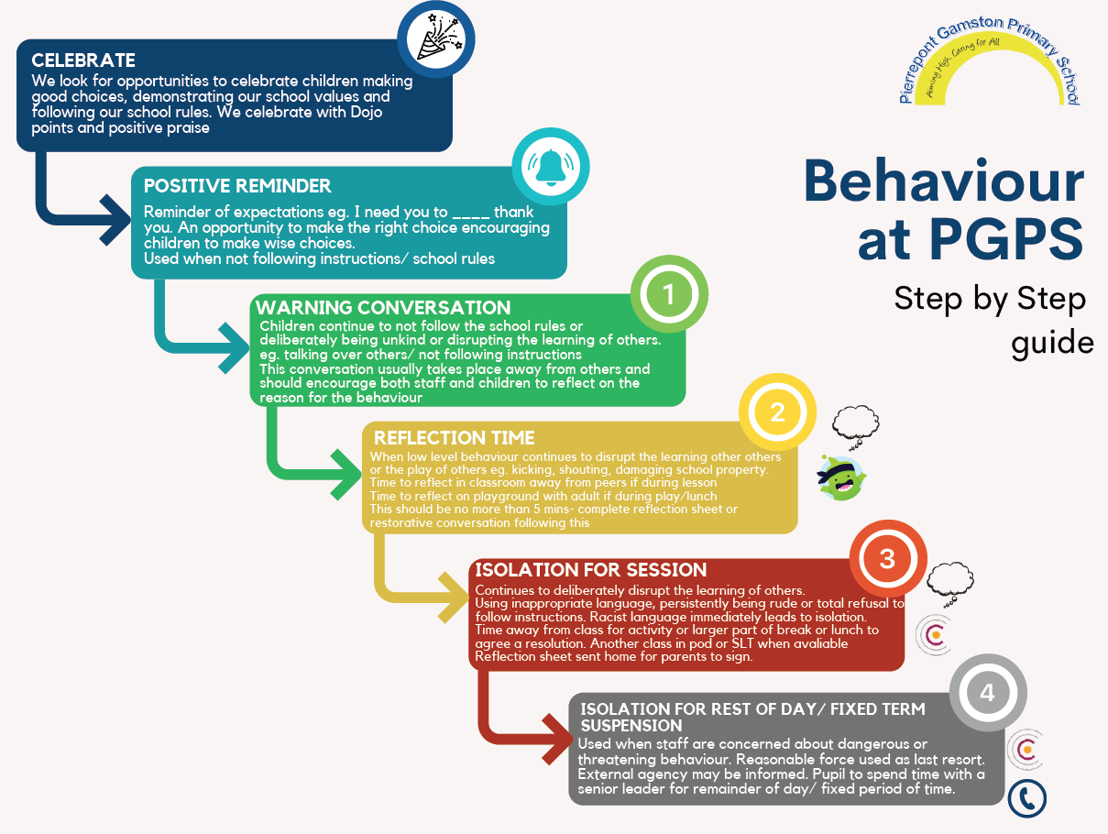
Appendix 1 – Managing incidents and agreed sanctions for managing behaviour
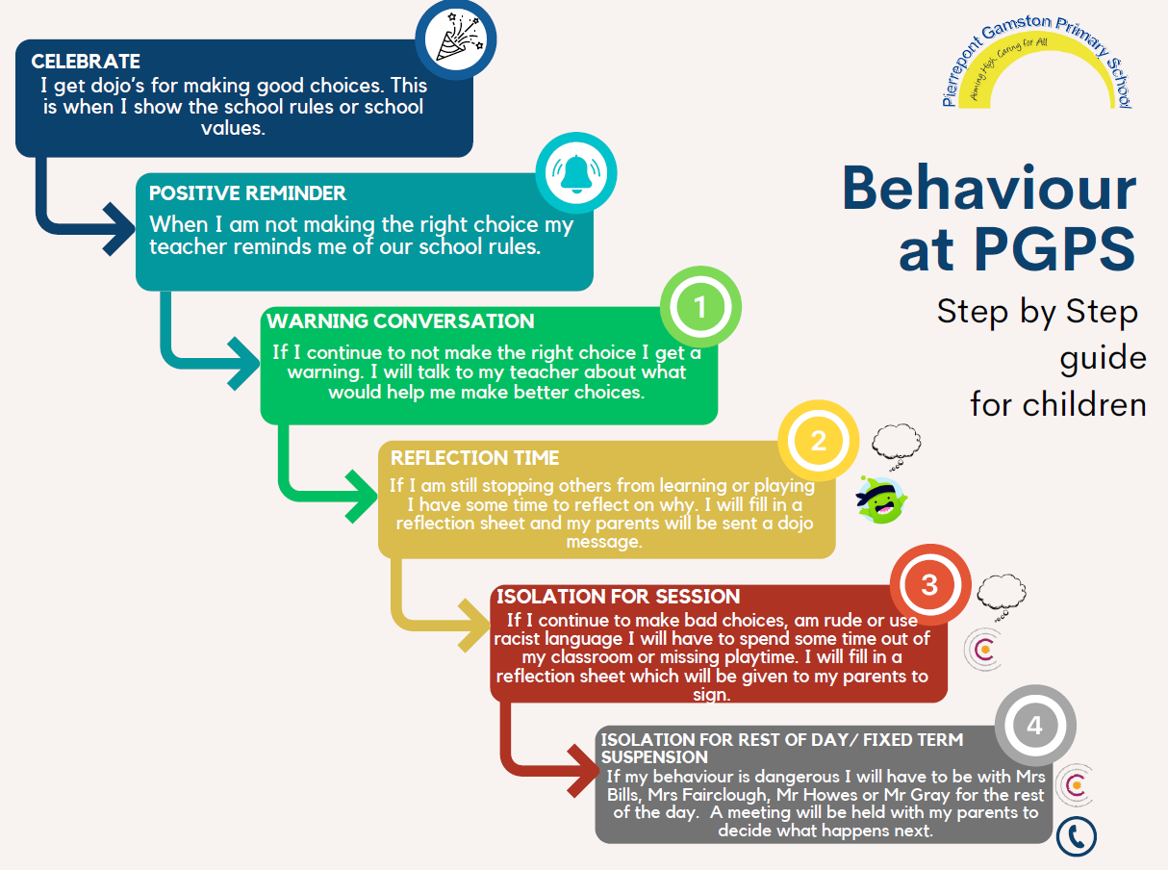
-
Appendix 2- Managing incidents and agreed sanctions for managing behaviour for children

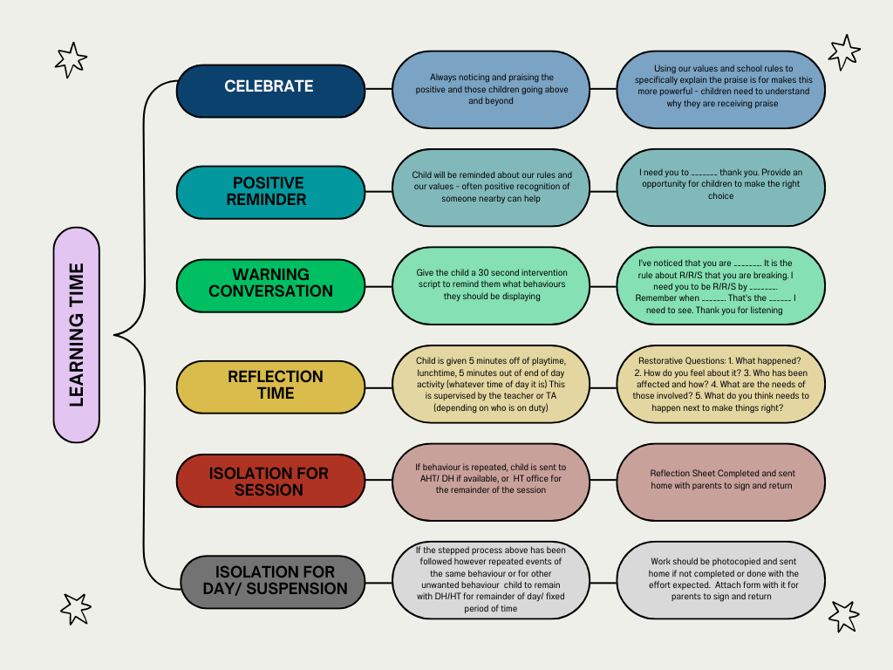
Appendix 3- Behaviour Scripts for learning time

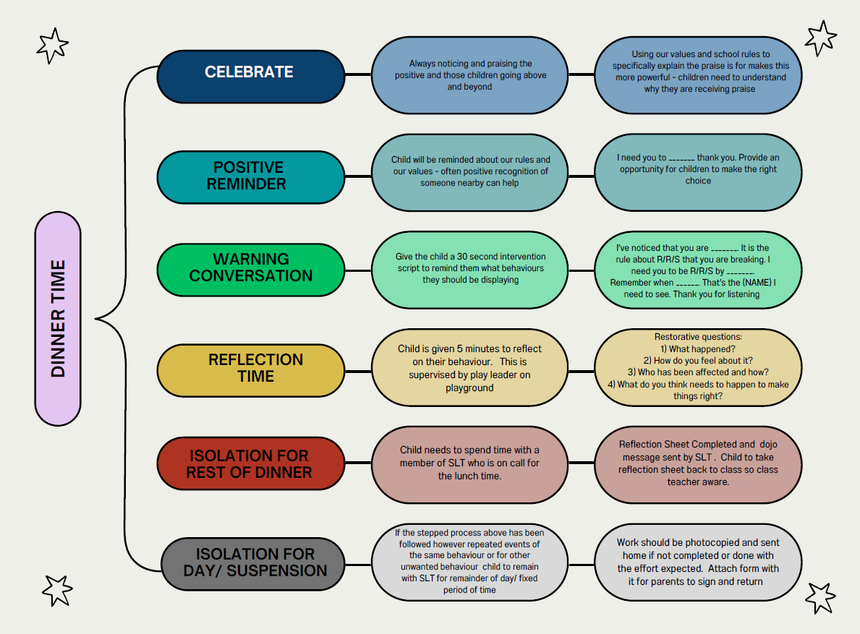
Appendix 4- Behaviour Scripts for playtime and dinner time

Appendix 5 – CPOMS Behaviour Log
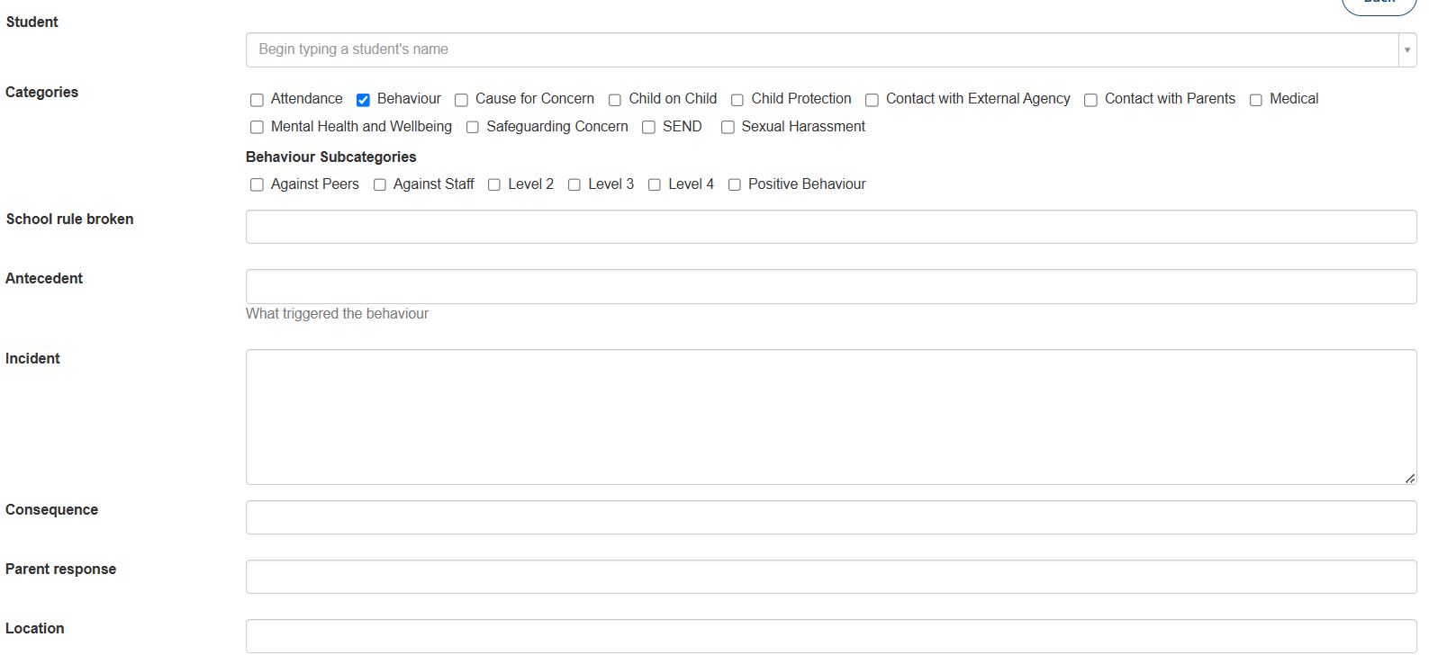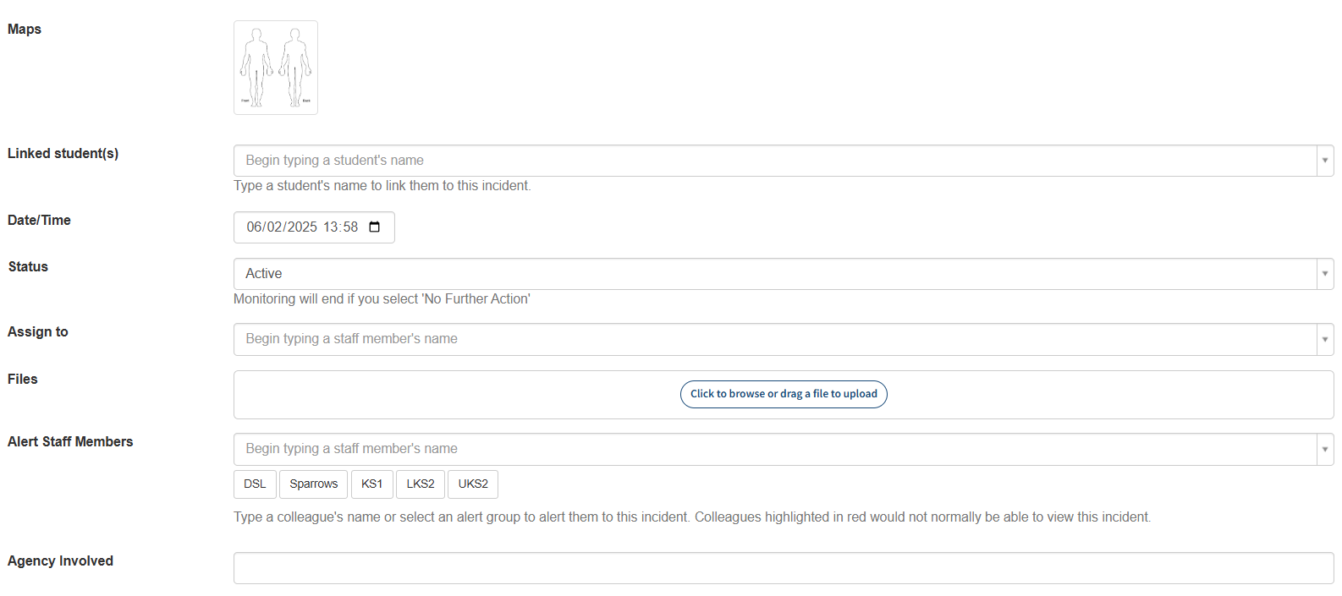

Appendix 6- Behaviour reflection sheets

