Pierrepont Gamston Primary School

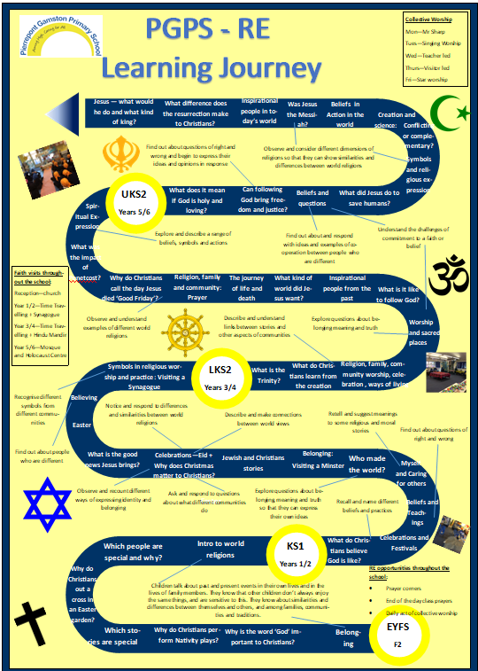
RE Policy

Introduction
This Religious Education Policy outlines the teaching, organisation and management of RE teaching and learning at Pierrepont Gamston Primary School, supporting the overall aims, values and ethos of the school and following the Nottinghamshire Agreed Syllabus: Religious Education for all 2021. At our school, R.E has a special place in our life and work as we offer the distinctive curriculum of a Voluntary Aided school.

We believe that Religious Education develops the children’s knowledge and understanding of the faiths and beliefs of people, often involving the worship of God, which contribute to the plural society. We enable children to develop a sound knowledge, not only of Christianity, but also of other major world religions. Religious Education is also concerned with the deep meaning that individuals and groups make of their own experiences and how this helps them give purpose to their lives. Children reflect on what it means to have a faith and to develop their own spiritual knowledge and understanding.

‘RE provokes challenging questions about meaning and purpose in life, beliefs about God, ultimate reality, issues of right and wrong and what it means to be human.’

Agreed Syllabus for RE in Nottinghamshire 2021, p9

As a school we have created a shared definition of Spirituality which we use class reflection areas and collective worship time to explore: “Spirituality is a journey of reflection, learning and growth, not a destination to be reached. We consider our relationship with ourselves, others, our world and God.”

Each of our values then reflects on living our this spiritual journey (appendix 3) and the ‘Ows’ ‘Wows’ and ‘Nows’ of life (appendix 4)

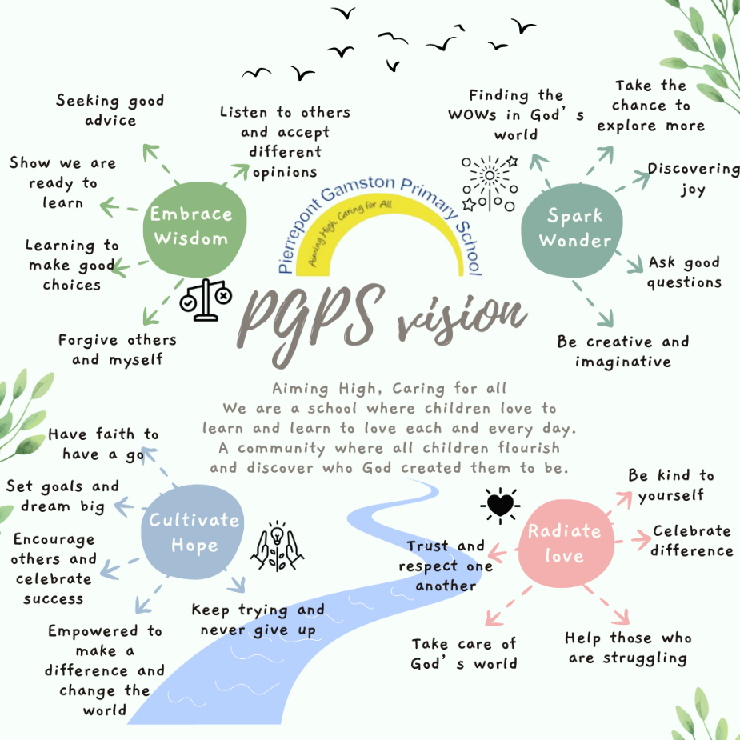
Values

Our school curriculum is underpinned by 4 distinctly Christian values – to Embrace Wisdom, to Cultivate Hope, to Spark Wonder and to Radiate Love.

Within our school, everyone is equally valued and treated with respect. We believe that everyone is made in the image of God, which means that everyone has an equal opportunity to achieve and will be challenged and supported to ensure that they continue to grow and learn within all areas of the curriculum.

As a school, we have developed habits for how each of these values are lived out. We further support children’s understanding with individuals who have shown each value and stories from the bible which demonstrate each.

Each value has a biblical passage which links to it and collective worship points children to recognising which value/s the message links to.

Intent
Our aim is to ensure that all children will:
- Learn how to study religions and worldviews systematically, making progress by reflecting on the impact of religions and worldviews on contemporary life locally, nationally and globally to increasing levels of complexity and depth.
- Gain and deploy the skills needed to interpret and evaluate evidence, texts and sources of wisdom or authority.
- Learn to articulate clear and coherent accounts of their personal beliefs, ideas, values and experiences while respecting the right of others to have different views, values and ways of life.
Agreed Syllabus for RE in Nottinghamshire 2021, p9

Further aims in RE are:
- To stimulate and maintain children’s curiosity, interest and enjoyment in RE. (Spark wonder—discovering joy)
- To develop an understanding of the influence of beliefs, values and traditions on individuals, communities, societies and cultures. (Radiate love- celebrate difference)
- To encourage children to develop an understanding of what it means to be committed to a religious tradition. (Radiate love- celebrate difference, Cultivate hope – empowered to make a difference and change the world)
- To help children to develop an awareness of spiritual and moral issues in life experiences and develop the ability to make reasoned and informed judgements about these, with reference to the teachings of some of the main religions represented in the UK. (Cultivate hope- keep trying and never give up, Radiate Love- take care of God’s world, Spark wonder- finding the Wows in God’s world)
- To develop positive attitudes of respect towards other people who hold different views and beliefs, and towards living in a society of diverse religions. (Embrace wisdom – Listen to others and accept different opinions)
- To enhance children’s spiritual, moral, social and cultural development by:
- developing awareness of the fundamental questions of life raised by human experiences, and of how religious teachings can relate to them (Spark wonder- ask good questions)
- responding to such questions with reference to the teachings and practices of religions, relating them to their own understanding and experience (Embrace wisdom – seeking good advice)
- reflecting on their own beliefs, values and experiences in the light of their work (Cultivate hope- encourage others and celebrate success)

We will achieve these aims by using the programme of study stated in the Agreed Syllabus, the Understanding Christianity resource, and the three areas of learning:
- Know about and understand a range of religions and world views.
- Express ideas and insights about the nature, significance and impact of religions and world views.
- Gain and deploy skills needed to engage seriously with religions and global world views.

There are strong connections between the programmes of study and British values, global learning, community cohesion, respect for all, PSHE and SMSC and the implementation of these three areas of learning will greatly enhance the development of these within the primary curriculum.

Children will use topic specific vocabulary (appendix 2) to support their researching, planning, making and evaluating.

Implementation

Curriculum Time
In order to deliver the aims and expected standards of the syllabus a minimum of 5% curriculum time is strongly recommended. In practice, this means that the following is allocated to the teaching of RE:
Reception & Key Stage 1: 36 hours of tuition per year (equivalent to 50 minutes a week).
Key Stage 2: 45 hours of tuition per year (equivalent to an hour a week).
(Agreed Syllabus p. 14)
A flexible approach can often be good practice, and RE can be in ‘blocks’, or RE themed weeks can be used.
There are many links between RE and some other subjects, such as English, history and PSHE. However, when creative cross curricular planning is used, it must be ensured that RE objectives are clearly taught.

Religions and Beliefs to be studied – minimum requirements
4-5s Reception: Developing a growing sense of child’s awareness of self, their community and place within this. Children will encounter Christianity and other faiths found in the classroom.
5-7s KS1: A minimum of 2 religions are to be studied – Christianity and the recommended Judaism.
7-11s KS2: A minimum of 3 religions are to be studied – Christianity, Hinduism and Islam.

In Foundation Stage, RE is introduced in line with the EYFS Statutory Framework 2021 and should, through planned, purposeful play and through a mix of adult-led and child-initiated activity, provide opportunities for: Communication and Language; Personal, Social and Emotional Development; Understanding the World; Expressive Arts and Design and Literacy.

In key stage 1, children gain and use skills to learn about, listen to others’ ideas and express their ideas about what it means to belong in a family, to a community or to a faith and about different stories from the Bible and the Torah in particular:
- beliefs, practices and places of worship in the Christian and Jewish faiths
- various celebrations in Christian, Jewish, Hindu and Muslim faiths
Children are taught to respect all people’s points of view.

In key stage 2, children gain and use skills to learn, listen to others’ ideas and express their ideas about the following:
- beliefs, teachings, wisdom, and values
- practices, festivals, ways of life in family and community
- worship, places of worship, locally in Nottinghamshire and including sacred places world-wide
- inspirational people and beliefs in action
- life questions and journeys through life
Children are given the opportunity to explore Christianity, Islam and Hinduism, in particular, but also Judaism, Sikhism and Buddhism to a lesser extent.

Delivery
Through an enquiry-based approach, all children will be encouraged to raise questions involving Religious Education. In answering these questions, children will encounter a variety of creative and enjoyable learning activities, which will enable children to develop their thinking skills ability. Examples are various: ICT techniques, role play and drama techniques, theatrical effects, art and design, use of religious artefacts, photos, visitors, educational visits, festival days/afternoons, various thinking skills activities, discussions, debates and investigative stories.

Understanding Christianity
We have incorporated the planning and concepts the Understanding Christianity document provides into our existing planning. Where the individual units are about religions other than Christianity, we have implemented the new Agreed Syllabus programme of study. Where the individual units are about Christianity, we have changed them to include the relevant Understanding Christianity units. These planning overviews are in the appendices.

Assessment and Reporting
Ongoing formative assessment plays a vital role in ensuring pupils retain and apply key knowledge effectively. Techniques such as Flashback 4, low-stakes but high-challenge quizzes, and targeted gap-filling using knowledge organisers are embedded regularly to support retrieval practice and reinforce learning. These strategies help identify misconceptions and strengthen pupils’ understanding over time. Additionally, one lesson per half term is dedicated to assessing the unit’s key sticky knowledge—core concepts identified as essential for long-term retention. This structured approach allows teachers to analyse assessment data meaningfully, adapt teaching accordingly, and build confidence that pupils can apply their RE knowledge in a thoughtful and informed way.
Reporting to parents occurs annually with a written report and also through parents’ consultations.

Children with Special Needs
We make appropriate provision to overcome all barriers to learning and ensure pupils with SEND needs have full access to the Nottinghamshire Agreed Syllabus, as stated in our SEN policy. We provide additional resources or support for children with special needs as required. This may be in the form of adaptions, differentiation by outcome, intervention, adult support or a personalised curriculum.

Request for Children to be Withdrawn
It is recognised that parents have the right to request that their children be withdrawn from Religious Education lessons and/ or Collective Worship – in its entirety or in part. We will proactively share information about the RE learning in the school. If you wish for your child to be withdrawn, please let us know.

Subject Leader Role
The role of a subject leader is to:
- Provide strategic lead and direction for a specific subject
- Support and offer advice to colleagues on issues related to the subject
- Monitor pupil progress and effectiveness of learning in that subject area
- Provide efficient resources management for the subject

It is the role of each subject leader to keep up to date with developments in their subject, at both national and local level. They review the way the subject is taught in school and plan for improvement. This development planning links to whole school objectives. Each subject leader reviews the curriculum plans for their subject, ensures that there is full coverage of the syllabus and that progression is planned into programmes of study.

Monitoring and Review
- Class teachers are responsible for the day to day planning, organisation and delivery of the curriculum subject.
- Subject leaders monitor the way their subject is taught throughout school and feedback to SLT and whole school where appropriate.
- An allocated governor is responsible for liaising with subject leaders to closely monitor the way the school teaches each subject.

Author: C Bills and B. Asquith
Date: February 2026
Review date: Autumn 2026

Appendix 1
FOUNDATION STAGE

AUTUMN –TERM 1 | SPRING – TERM 2 | SUMMER TERM 3
Belonging: who are we and how do we belong? | Which stories are special and why?  (BA planning) | Our wonderful world –  How can we care for living things and the earth?
Why is the word ‘God’ so important to Christians?  (UC Unit F1 – God/ Creation)  Why do Christians perform nativity plays at Christmas? (UC Unit F2 – Incarnation) | Which people are special and why? (Jesus – focus on miracles)  Why do Christians put a cross in an Easter Garden?  (UC Unit F3 – Salvation) | Introduction to world religions – Christianity, Judaism, Hinduism and Islam  (BA planning)

KS1 – Cycle A

 | AUTUMN –TERM 1 | SPRING – TERM 2 | SUMMER TERM 3
Cycle A | Jewish and Christian Stories: How and why are some stories important in religions?  What can we learn from these stories and from the Torah and the Bible?  (Noah, Abraham and Sarah, Moses, David, Joseph, Daniel, Hanukah)  (Agreed Syllabus Unit 2.4) | What is the good news Jesus brings?  (UC Unit 1.4 – Gospel) | Believing  What do Jewish people believe about God, creation, humanity and the natural world?  What are some ways Jewish people show their beliefs and how they belong?  (Agreed Syllabus Unit 2.2)
Cycle A | Why does Christmas matter to Christians?  (UC Unit 1.3 – Incarnation) | Easter  Who celebrates what and why?  (Original planning.  See Agreed Syllabus Unit 1.1 Celebrations and Festivals for objectives)  KS1 lead the Easter Service | Symbols in religious worship and practice  In what way are churches/ Synagogues important to believers?  (Agreed Syllabus Unit 1.4)  (Trip – visit to a Synagogue)

KS1 – Cycle B

 | AUTUMN –TERM 1 | SPRING – TERM 2 | SUMMER TERM 3
Cycle B | What do Christians believe God is like?  (UC Unit 1.1 – God) | Beliefs and Teachings  Stories of Jesus: What can we learn from them?  How do religious stories make a difference to people’s lives?  (Agreed Syllabus Unit 1.3) | Who made the world?  (UC Unit 1.2 – Creation)
Cycle B | Celebrations and Festivals  Who Celebrates what and why?  (Christmas, Hanukkah and Diwali)  (Agreed Syllabus Unit 1.1) | Myself and Caring for others  How do we show we care for others?  Why does it matter?  (Religious stories – Lost Sheep, Psalm 23)  (Agreed Syllabus Unit 1.2)  + Why does Easter matter to Christians?  (UC Unit 1.5 – Salvation)  KS1 lead the Easter Service | Belonging  What does it mean to belong?  What is it like to belong to the Christian religion in Nottinghamshire today?  (Trip to a traditional church. Eg. St. Giles)  (Agreed Syllabus Unit 2.3)

Lower Key Stage 2
Autumn |  | Spring | Summer
Cycle B | What is the trinity?  (UC Unit 2A.3 – Incarnation/ God)  LKS2 lead Harvest Service | Religion, family, community worship, celebration, ways of living  How do Hindus practice their faith?  What are the deeper meanings of some Hindu Festivals?  (Agreed Syllabus Unit 4.4) | What is it like to follow God?  (UC Unit 2A.2 – People of God)
Cycle B | What do Christians learn from the creation story?  (UC Unit 2A.1 – Creation/ Fall) | Worship and sacred places:  Where, how and why do people worship?  (Agreed Syllabus Unit 3.3)  (Trip to a Hindu temple) | Inspirational people from the past  What can we learn from inspiring people in sacred texts and in the history of religions?  (Agreed Syllabus Unit 3.4)

Lower Key Stage 2
Autumn |  | Spring | Summer
Cycle A | What kind of world did Jesus want?  (UC Unit 2A.4 – Gospel)  LKS2 lead Harvest Service | Religion, family and community: Prayer  How do religious families and communities practice their faith? The example of prayer.  (Muslim beliefs and prayer, Lord’s prayer for Christians)  (Agreed Syllabus Unit 3.2) | When Jesus left, what was the impact of Pentecost?  (UC Unit 2A.6 – Kingdom of God)
Cycle A | The journey of life and death  Why do some people think life is like a journey?  Where do we go?  What do different people think about life after death?  (Christianity, Islam and Hinduism)  (Agreed Syllabus Unit 4.1 | Why do Christians call the day Jesus died ‘Good Friday’?  (UC Unit 2A.5 – Salvation)  (Trip to Southwell Minster, Time Travelling) | Spiritual Expression  Christianity, music and worship: what can we learn?  (Christianity and non-religious ideas)  (Agreed Syllabus Unit 4.3)

Upper Key Stage 2
 | Autumn | Spring | Summer
Cycle B | Beliefs in Action in the world  What was the Kinder transport?  Who resisted and who rescued?  How can we be Upstanders today?  How do religions and beliefs respond to global issues of human rights, fairness, social justice and the importance of the environment?  (Christianity, Islam, Hinduism, Judaism and non-religious worldview)  (Agreed Syllabus Unit 6.3 and 6.4)  (Trip to Beth Shalom) | Inspirational people in today’s world  What can we learn from great leaders and inspiring examples in today’s world?  (Martin Luther King, Ghandi, Desmond Tutu, Dr Hany El Banna – founder of Islamic Relief)  (Agreed Syllabus Unit 5.1) | What would Jesus do?  (UC Unit 2B.5 – Gospel)
Cycle B | Was Jesus the Messiah?  (UC Unit 2B.4 – Incarnation)  UKS2 lead Christmas Service | What difference does the resurrection make to Christians?  (UC Unit 2B.7 – Salvation) | What kind of King is Jesus?  (UC Unit 2B.8 – Kingdom of God)

Upper Key Stage 2
Autumn |  | Spring | Summer
Cycle A | What does it mean if God is holy and loving?  (UC Unit 2B.1 – God) | Beliefs and questions  How do people’s beliefs about God, the world and others have impact on their lives?  (Islam, Hinduism and non-religious worldviews)  (Agreed Syllabus Unit 6.3)  Beliefs in action in the world  How are religious and spiritual thoughts and beliefs expressed in arts, architecture and in charity and generosity?  (Agreed Syllabus Unit 5.4)  (Trip to a Mosque) | Symbols and Religious Expression  How do people express their religious and spiritual ideas on pilgrimages?  (Islam, Hinduism, Christianity and non-religious worldviews)  (Agreed Syllabus Unit 4.2)
Cycle A | How can following God bring freedom and justice?  (UC Unit 2B.3 – People of God)  UKS2 lead Christmas Service | What did Jesus do to save human beings?  (UC Unit 2B.6 – Salvation) | Creation and Science: Conflicting or Complementary?  (UC Unit 2B.2 – Creation/ Fall)

Appendix 2

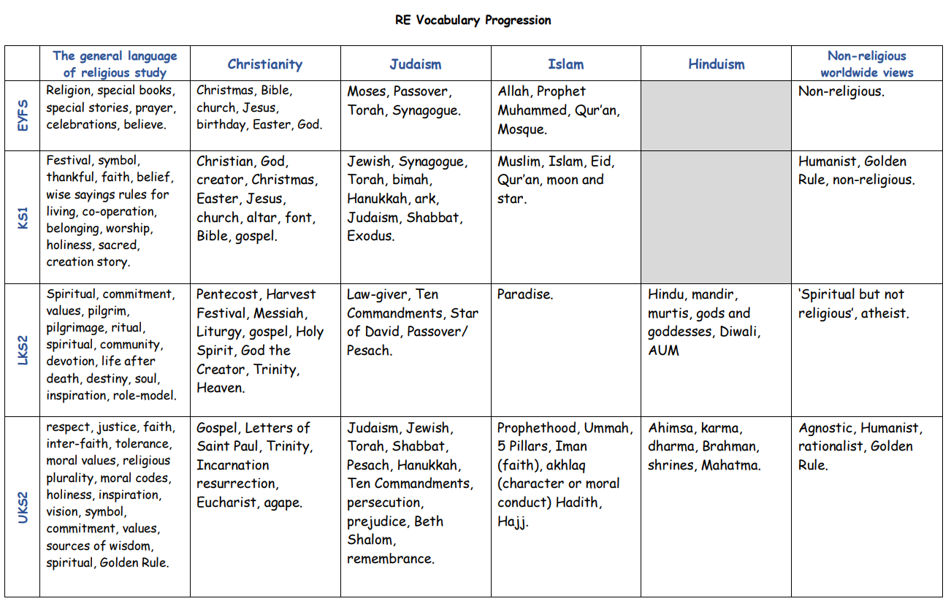

Appendix 3- How our values link to Spirituality
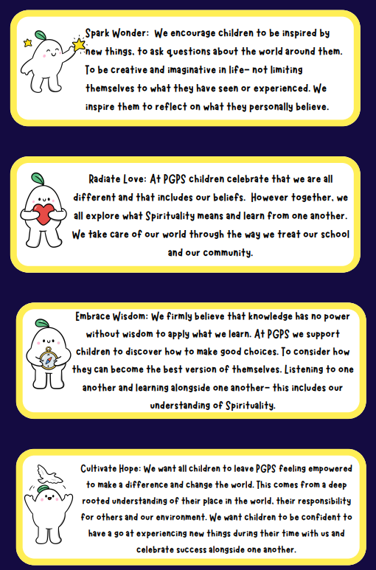

Appendix 4- The Ows, Wows and Nows of spirituality at PGPS


