

Equality Policy

October 2025

EQUALITY STATEMENT
Legal Duties

At Pierrepont Gamston Primary School we welcome our duties under the Equality Act 2010. The general duties are to:

- eliminate discrimination,
- advance equality of opportunity
- foster good relations

We understand the principal of the act and the work needed to ensure that those with protected characteristics are not discriminated against and are given equality of opportunity. Protected characteristics make up the part of a person’s identity that makes them who they are, such aspects or characteristics are protected from discrimination. Everyone in Britain is protected from unlawful behaviour by the Act.

The protected characteristics are as follows:
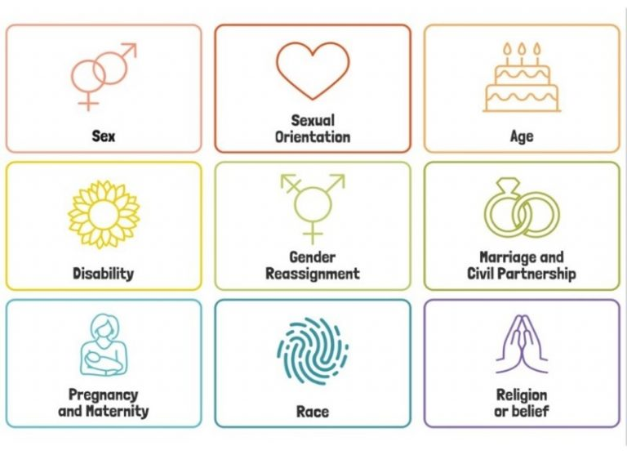
- sex
- sexual orientation
- age
- disability
- gender reassignment
- marriage and civil partnership (for employees)
- maternity and pregnancy
- race
- religion and belief

We recognise that these duties reflect international human rights’ standards as expressed in the UN Convention on the Rights of the Child, the UN Convention on the Rights of People with Disabilities, and the Human Rights Act 1998. In developing our policy, we have therefore also taken them into consideration.

We make use definitions and child friendly language regarding these protected characteristics making use of picture news helpful definitions which are available to view in Appendix 1.

To meet our general duties, listed above, the law requires us to carry out some specific duties to demonstrate how we meet the general duties.
These are to:

- Publish Equality Information – to demonstrate compliance with the general duty across its functions (We will not publish any information that can specifically identify any individual).
- Prepare and publish equality objectives which we will review on an annual basis.
- Consult all our stakeholders in the development of our equality objectives and report on progress against our objectives on an annual basis.

To do this effectively we will collect data related to the protected characteristics above and analyse this data to determine our focus for our equality objectives. The data will be assessed across our core provisions as a school, but we will also analyse available data relating to the context of our local community, including hate crime data and demographic information. In relation to school provision, we will pay particular attention to the following functions:
- Admissions
- Attendance
- Attainment
- Exclusions
- Prejudice-related incidents
- Curriculum
- Complaints/compliments

Our objectives will detail how we will ensure equality is applied to the services listed above. However, where we find evidence that other functions have a significant impact on any group, we will include work in this area.

We also recognise that our work on equality is central to the successful promotion of fundamental British values, especially in relation to the values of respect and tolerance and the rule of law. We will therefore ensure that our curriculum helps to prepare pupils for life in modern Britain. We will work proactively to address all forms of prejudice and discrimination, including derogatory and discriminatory language. We will mainly do this through the delivery of our Relationships, Sex and Health Education Curriculum / PSHE Curriculum. We will also utilise all other subject areas to foster positive relations and to ensure that we consciously cultivate opportunities to challenge stereotypes and support positive identity development for all our pupils. We will regularly audit our resources, displays, lesson content and assessment processes to ensure that they meet the needs of all groups. We will scrutinise outcomes across a range of measures, analyse the results and address any identified areas of concern.

We have mapped out British Values alongside our Whole School Values so that children can see the opportunities and links between these as follows:
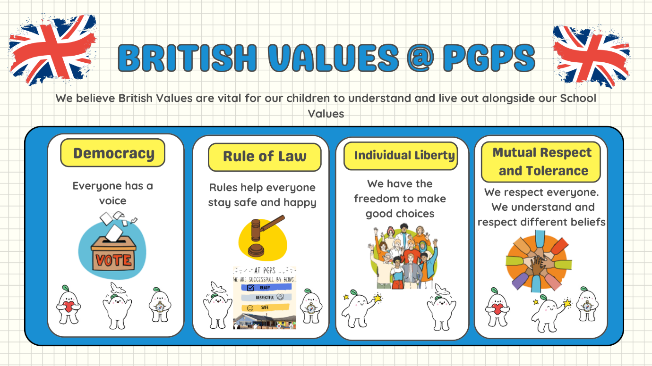
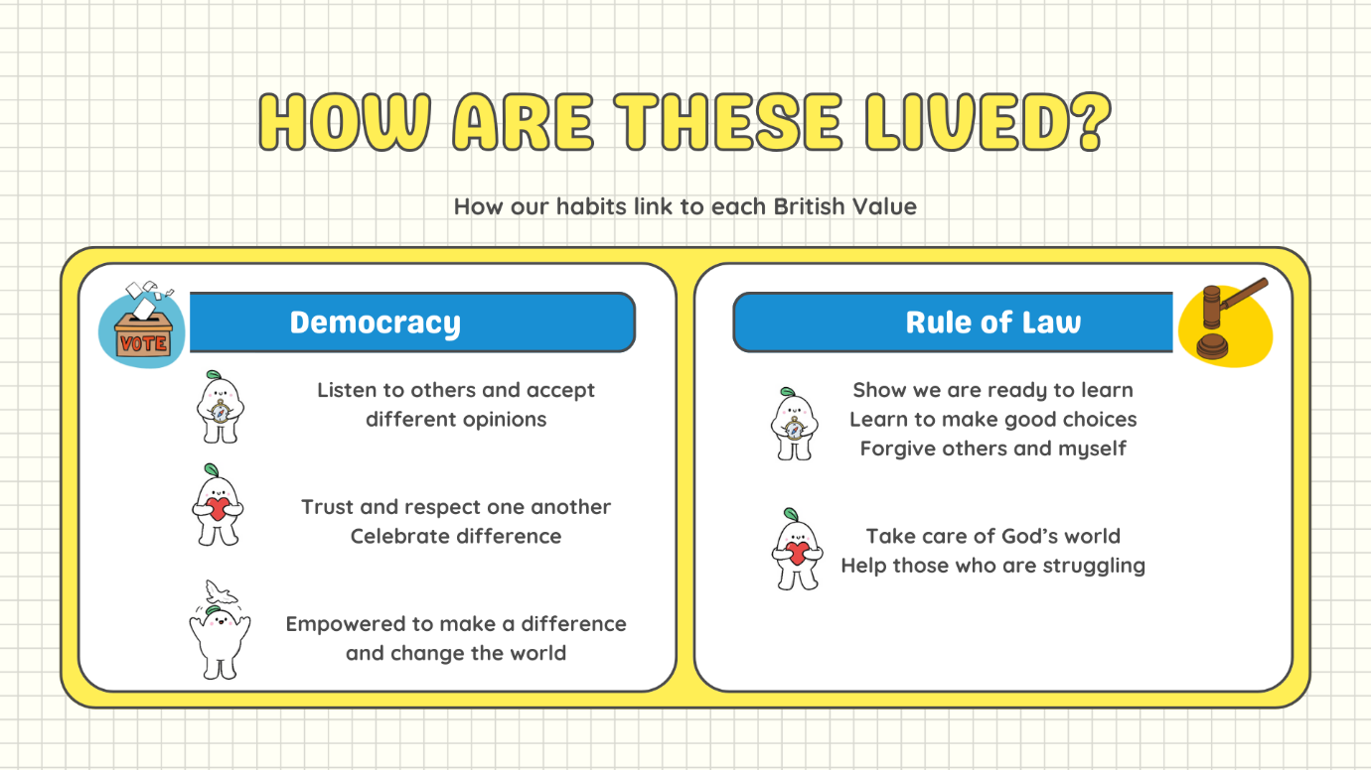
In endeavouring to fulfil our legal duties, we will:

- Recognise and respect diversity
- Foster positive attitudes and relationships, and a shared sense of belonging
- Observe good equalities’ practice, including staff recruitment, retention, and development
- Aim to identify, reduce, and remove existing inequalities and barriers
- Consult and involve widely- this includes NCC and our local community
- Regularly review our progress

Definitions

Discrimination is unfair treatment towards another or a group of individuals who share one or some of the protected characteristics.

Direct Discrimination occurs when someone is treated less favourably than others because of a protected characteristic.

Discrimination by Association occurs when someone is treated less favourably because someone they are associated with, such as a friend, family member or carer, has a protected characteristic.

Direct Discrimination by Perception occurs when someone is treated less favourably because someone believes they have a protected characteristic, regardless of whether their perception is correct or not.

Indirect discrimination can be more difficult to identify and sometimes is not intended. It can occur due to a lack of understanding of the law or a genuine error of judgement about an individual. For example, a policy that is applied to all individuals equally may inadvertently disadvantage individuals or groups who have a protected characteristic. It is therefore essential that all aspects of school life and policies are scrutinised carefully to avoid any unlawful provision, criterion, or practice.

Victimisation occurs when an individual has either raised a complaint or grievance that they have been discriminated against based on having a protected characteristic; or has supported someone who has raised a complaint or grievance.

Harassment is any form of unwanted behaviour intended to violate an individual’s dignity or create an environment which may be described as hostile, degrading, humiliating or offensive. The victim will be subject to this harassment based on a protected characteristic or the perception that they have a protected characteristic, or because they are associated with someone who has a protected characteristic.

Prejudice can be conscious or unconscious and involves stereotypes, prejudgements, and beliefs (which are usually negative) about an individual, or group of people, based on a protected characteristic.

Our Ethos

Our school takes its Christian Foundation as our starting point. At the heart of the foundation is the truth that we are all created in the image of God and loved by him. We aim to serve our community by providing an education of the highest quality within the context of Christian belief and practice. At PGPS we encourage all stakeholders to understand the meaning and significance of faith. We strive to promote Christian values in everything that we do.

Therefore our school is a place where:

- We encourage all children to aim high, developing their own unique God-given gifts and potential to the best of their ability, whilst celebrating the gifts of others.

- We will develop a sense of community in which all children and adults will be encouraged to recognise their responsibility to care for each other and for God’s world.

- We expect to learn about Christian faith and religious diversity, develop faith and spirituality and express faith practically in daily living.

The school will preserve and develop its Christian character in accordance with the principles of the Church of England and in partnership with churches at parish and diocesan level.

In our school everyone is equally valued and treated with respect. Everyone has an equal opportunity to achieve and will be challenged and supported to ensure that they continue to grow.

School Values: Spark Wonder, Embrace Wisdom, Cultivate Hope and Radiate Love.

Roles and Responsibilities

We believe that promoting Equality is the whole school’s responsibility.
School Community | Responsibility
Governing Body | Involve and engage the whole school community in identifying and understanding equality barriers and in the setting of objectives to address these.  Monitor progress towards achieving equality objectives.  Publish data and publish equality objectives.  Ensure that staff have access to appropriate training and resources.
Head Teacher / Principal | As above including:  Promote key messages to staff, parents, and pupils about equality and what is expected of them and can be expected from the school in carrying out its day-to-day duties.  Ensure that all in the school community receive adequate training to meet the need of delivering equality, including pupil awareness.  Ensure that all staff are aware of their responsibility to record, report and respond appropriately to prejudice-related incidents.
Senior Management Team | To support the Head / Principal as above  Ensure fair treatment and access to services and opportunities.  Ensure that all staff are aware of their responsibility to record, report and respond appropriately to prejudice-related incidents.
Teaching Staff | Help in delivering the right outcomes for pupils.  Uphold the commitment made to pupils and parents/carers on how they can be expected to be treated.  Design and deliver an inclusive curriculum.  Record, report and respond appropriately to prejudice-related incidents.
Non -Teaching Staff | Support the school and the governing body in delivering a fair and equitable service to all stakeholders.  Uphold the commitment made by the Head Teacher/Principal on how pupils and parents/carers can be expected to be treated.  Support colleagues within the school community.  Record, report and respond appropriately to prejudice-related incidents.
Parents/Carers | Take an active part in identifying barriers for the school community and in informing the governing body of actions that can be taken to eradicate these.  Take an active role in supporting and challenging the school to achieve the commitment given to the school community in tackling inequality and achieving equality of opportunity for all.
Pupils | Support the school to achieve the commitment made to tackling inequality.  Uphold the commitment made by the Head Teacher on how pupils and parents/carers, staff and the wider school community can be expected to be treated.  Report prejudice-based incidents to a trusted adult.
Local Community Members | Take an active part in identifying barriers for the school community and in informing the governing body of actions that can be taken to eradicate these  Take an active role in supporting and challenging the school to achieve the commitment made to the school community in tackling inequality and achieving equality of opportunity for all.

We will ensure that the whole school community is aware of the Equality Policy and our published equality information and equality objectives by publishing them on the school’s website: https://www.pgps.org.uk/

Preventing and Addressing Prejudice Related Incidents

We define prejudice-based incidents/bullying in the following way:

Prejudice-related incidents/bullying – derogatory and discriminatory language and behaviour including that which is racist, homophobic, biphobic, transphobic and disablist in nature. This language and behaviour may be directed towards people because of their race/ethnicity/nationality; because they are lesbian, gay, bisexual, or trans, or are perceived to be, or have a parent/carer, sibling, or friend who is, or because they have a learning or physical disability. It may include misogyny or misandry and be sexist in nature. Such language and behaviour are generally used to refer to something or someone as inferior.

At Pierrepont Gamston Primary School we encourage open discussions around differences between people, we actively challenge prejudice and we celebrate diversity. This school is opposed to all forms of prejudice and we recognise that children and young people who experience any form of prejudice-related discrimination may fair less well in the education system. We recognise that prejudice-based bullying is a form of child-on-child abuse and is therefore a safeguarding concern, as outlined in Keeping Children Safe in Education 2025. We adopt a contextual safeguarding, trauma-informed and strengths-based approach to bullying and child-on-child abuse. We are committed to working with families and outside agencies to proactively prevent incidents and to create an environment in which all members of our school community feel welcomed, accepted, and safe. We believe every member of our community should be treated with respect and should not be subjected to prejudice or discrimination in any form. This includes staff, parents/carers, governors/trustees, and visitors to our school.

We provide both our pupils and staff with an awareness of the impact of prejudice to prevent any incidents. We will endeavour to proactively tackle all forms of prejudice by ensuring our curriculum is representative of all sections of society and the contributions made by people with different characteristics are consciously embedded across all subjects. In doing so, we will challenge stereotypes and work towards inclusivity and identity-safe classrooms where everyone feels validated, accepted, safe and a sense of belonging.
If incidents still occur, we will address them immediately ensuring that appropriate levels of support are provided to those affected; that we thoroughly investigate all reports/allegations; and that we will apply appropriate sanctions and address offending behaviours through a programme of education. All adults in our school community are expected to comply with the school’s Code of Conduct. Any allegations made against staff will be investigated in line with our policies and procedures relating to staff conduct and behaviour. Any staff member/parent/carer, governor/trustee or visitor to the school, who is subjected to prejudice-based abuse can also expect to have their complaint thoroughly investigated and will be supported in accordance with their wishes.

We review our practice following each incident including what more we might do to prevent further incidents. We recognise that we must not become complacent and will regularly evaluate satisfaction levels in respect of how we have responded to any reports or concerns raised.

Children (including bystanders)

It is important to understand that a victim may not find it easy to tell staff about their abuse verbally. Children can show signs or act in ways that they hope adults will notice and react to. In some cases, the victim may not make a direct report. We recognise that in some instances another child may report on another child’s behalf. All children will know how to report concerns or incidents involving prejudice or discrimination.

We ask that all children report any concerning behaviour to a member of school staff – this can be any member of teaching or non-teaching staff, including a class teacher, a TA, the Head teacher, a lunchtime supervisor, or a member of the office team. We talk about trusted adults regularly in class to remind our children of who they can report concerns to. The member of staff will listen to the child and make an initial note of their concerns, they will then discuss next steps with them and reassure them that they will be supported. In line with the statutory guidance provided in Keeping Children Safe in Education 2025, we will never promise a child that we will not tell anyone about a report of any form of abuse, as this may not be in the best interests of the child. The member of staff will make a formal record of the concern/report on the school’s recording system and other relevant members of staff will be alerted. The member of staff will directly alert the school’s Designated Safeguarding Lead if the report is deemed urgent or if a child is considered at risk.

We understand that some children may find it difficult to tell a member of staff about their concerns verbally. We therefore have additional reporting mechanisms in place, which are relevant to the age and stage of the pupil. Some children will have higher levels of adult support due to additional needs E.G. being non-verbal.

Parents/carers

We understand that parents and carers may well struggle to cope with making or receiving a report that their child has been the victim of or is an alleged perpetrator of a prejudice-based incident.

We ask that if parents/carers have concerns about their child experiencing or allegedly perpetrating any such incident, that they contact the school’s Designated Safeguarding Lead/Deputies (in person/via telephone call/via email) to explain their concerns. The Designated Safeguarding Lead/Deputies will take an initial note of the concerns but may ask to schedule a meeting to allow for more time to discuss the concerns in detail. Following the report and/or the meeting, the Designated Safeguarding Lead/Deputies will make a formal record of the report in the child’s CPOMS file and other relevant members of staff will be alerted. The Designated Safeguarding Lead/Deputies will seek advice from Statutory Services if the report is deemed urgent or if a pupil is considered at risk.

We ask that parents/carers to come directly to the school with their concerns rather than discussing them with other members of the school community in person or online.

Our school remains committed to supporting pupils and their families. We will endeavour to ensure that all parties are kept informed of progress and any developments, but we will also need to show due regard to GDPR (General Data Protection Regulations) and any ongoing investigations by external agencies where a serious incident has been reported (e.g., the incident is a hate crime). This may mean, at times, that we are not able to provide or share information or updates immediately.

If a parent/carer is not satisfied with our school’s actions, we ask that they follow our school’s complaint policy and procedures. This is available online from our school website and on request from the school office.

Staff

Our staff work closely with our children and therefore may notice a change in a child’s behaviour or attitude that might indicate that something is wrong before receiving a report from a child or a member of the school community. If staff have any concerns about a child’s welfare or are concerned that a child is displaying behaviours that may show they have been the victim of or that they are perpetrating prejudice-based abuse, they should act on them immediately rather than wait to be told.

We ask that staff report their concerns to the Designated Safeguarding Lead/Deputies. The member of staff receiving the report will take an initial note of the concerns and will then make a formal record of the concerns, which will be passed to the Safeguarding Lead. The Designated Safeguarding Lead/Deputies will seek advice from Statutory Services if the report is deemed urgent or if a pupil is considered at risk.

Breaches

Breaches to this statement will be dealt with in the same way that breaches of other school policies are dealt with, as determined by the head teacher and governing body.

Policy Development

This policy has been developed to reflect the most recent Keeping Children Safe in Education (KCSiE) Statutory Guidance (1st September 2025) and was formulated in consultation with members of the whole school community.

This policy is available online or on request from the school office.

Links with other policies

You may find it helpful to read this Equality Policy alongside the other following school policies:

Policy | How it may link
Safeguarding Policy | Includes information about child protection procedures and contextualised safeguarding
Behaviour Policy | Includes details about the school’s behaviour system including potential sanctions for pupils
Anti-Bullying policy | Includes information about bullying behaviours and vulnerable groups
E-Safety / Acceptable Use Policies | Includes information about children’s online behaviour and details about online bullying/cyberbullying
Child-on-Child Abuse Policy | Includes links to bullying
RSHE / PSHE Policy | Includes information about our school’s RSHE programme and how we teach about healthy relationships, friendships, diversity and bullying
Complaints Policy | Includes information about how to make a complaint if you are not satisfied with the school’s response

Monitor and Review

As a minimum, we will review our objectives in relation to any changes in our school profile at least every three years. Our objectives will sit in our overall school improvement plan and therefore will be reviewed as part of this process.

Date Approved by the Governing Body: November 2025

Date to be reviewed by the Governing Body: Autumn term 2026

Useful Links:

- Equality Act 2010: guidance - GOV.UK (www.gov.uk)
- Convention on the Rights of the Child (CRC) | Equality and Human Rights Commission (equalityhumanrights.com)
- UN Convention on the Rights of Persons with Disabilities (CRPD) | Equality and Human Rights Commission (equalityhumanrights.com)
- The Human Rights Act | Equality and Human Rights Commission (equalityhumanrights.com)
- Dealing with Prejudice: Best Practice Guide for Nottinghamshire Schools and Academies, September 2022 (available through the TETC pages of the Nottinghamshire School’s portal)

Appendix 1- Picture news definitions and child friendly explanations of protected characteristics 

