Pierrepont Gamston VA Primary School



Collective Worship Policy

June 2025
Introduction

At Pierrepont Gamston Primary School worship has a special place in our life and work as we offer the distinctive contribution of a Voluntary Aided Church school. We provide an opportunity for children and staff to worship (which is quite distinct from a general coming together for a school assembly) in a contemporary Christian style, which is consistent with the beliefs and practices of the Church of England. Our worship is about engaging with God on a daily basis, which impacts our life together in school as well as influencing how we act out of it, living out the three strands of the diocese vision to have Compassion, Confidence and Courage.

In line with the DfES circular (1/94), which states that collective worship should be ‘wholly or mainly of a broadly Christian character’, we base our collective worship on the teachings of Christ and traditions of the Christian Church. However, we conduct our worship in a manner that is sensitive to the individual faith and beliefs of all members of the school. Parents have the legal right to withdraw their children from acts of worship on religious grounds, either partially or wholly. Any parents who wish to do so, should contact the headteacher.

Values

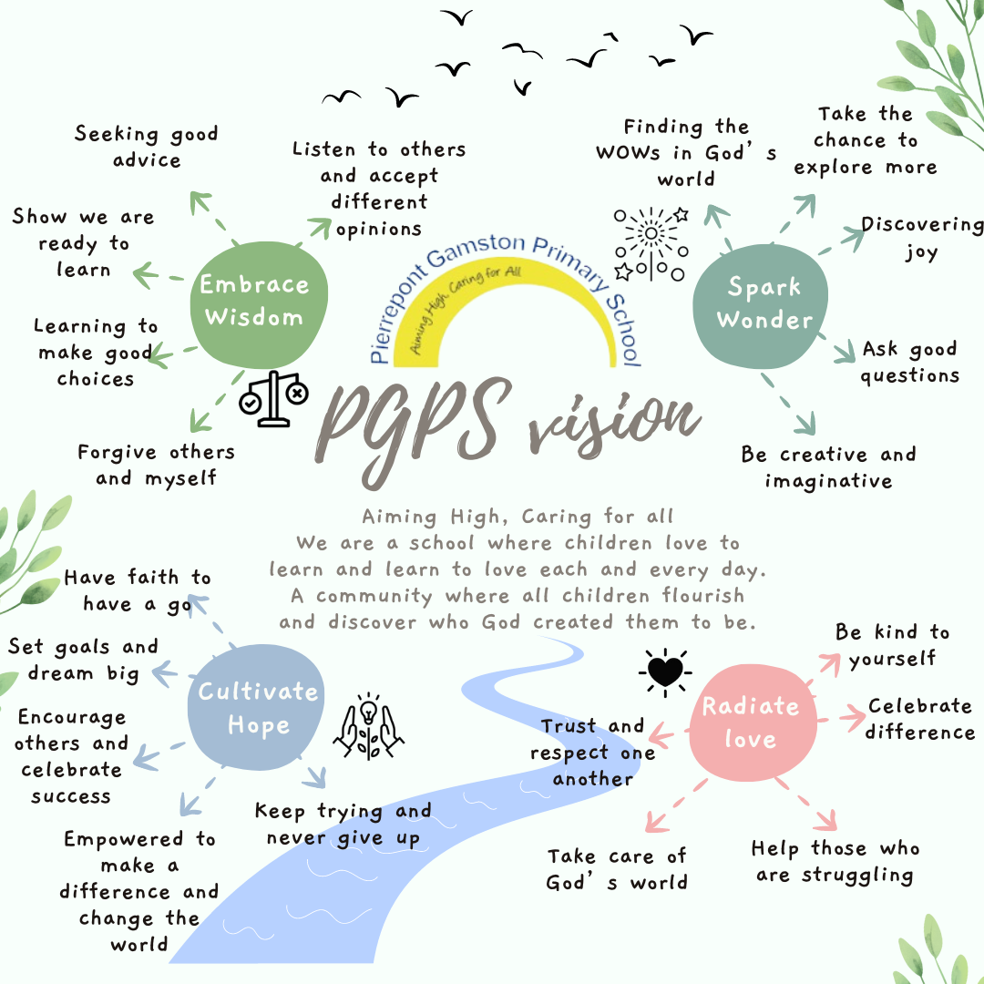
Our school curriculum is underpinned by 4 distinctly Christian values – to Embrace Wisdom, to Cultivate Hope, to Spark Wonder and to Radiate Love.

Within our school, everyone is equally valued and treated with respect. We believe that everyone is made in the image of God, which means that everyone has an equal opportunity to achieve and will be challenged and supported to ensure that they continue to grow and learn within all areas of the curriculum.

As a school, we have developed habits for how each of these values are lived out. We further support children’s understanding with individuals who have shown each value and stories from the bible which demonstrate each.

Each value has a biblical passage which links to it and collective worship points children to recognising which value/s the message links to.

Spirituality

As a school we have created a shared definition of Spirituality which we use class reflection areas and collective worship time to explore: “Spirituality is a journey of reflection, learning and growth, not a destination to be reached. We consider our relationship with ourselves, others, our world and God.”

Each of our values then reflects on living our this spiritual journey (appendix 1) and the ‘Ows’ ‘Wows’ and ‘Nows’ of life (appendix 2)

Purpose of collective worship

- To enable children and staff to appreciate their worth and value to God.
- To ensure spirituality is embedded in worship use of silence through reflection, contemplation, meditation and prayer. Children regularly are introduced to the ‘ows’ ‘wows’ and ‘nows’ of life
- To provide the opportunity to bring personal needs, and the needs of others, to God.
- To provide the opportunity for honouring, praising and giving thanksgiving to God.
- To encourage a sense of unity by providing the opportunity for the whole school community to meet together.
- To heighten awareness of the ultimate questions / realities of life by providing the opportunity to reflect and search for meaning.
- To experience moments of awe, wonder, thankfulness, mystery and joy.
- To provide the opportunity to celebrate Christian festivals.
- To celebrate gifts, talents and achievements.
- To share the central teachings of the Christian faith and develop a knowledge of the Bible.
- To establish, explore and reinforce Christian values.
- To encourage respect and care for God’s creation.
- To foster sensitivity to other religions, beliefs, values, cultures and traditions.
- To encourage children and staff to explore their own beliefs and understanding of God within a Christian framework.
- To provide a vocabulary of worship and an experience of a wide variety of worship forms.

Responsibilities

Governors

- Will fulfil their statutory duty, ensuring that collective worship meets legal requirements.

Headteacher

- Will liaise with the Lead Teacher to plan each term’s collective worship, ensuring that the key themes and the content of any materials are in keeping with the Christian ethos of the school.
- Will lead at least one worship per week and will oversee all acts of collective worship to ensure that the quality of delivery is of a consistently high standard.

Lead Teacher

- Will communicate with teachers and visitors to ensure that key themes are fully understood.
- Will liaise with the headteacher to identify themes, ensuring that quality materials are available to support delivery.
- Will liaise with the headteacher to support colleagues on the delivery of collective worship, identifying training needs where required.
- Will monitor the effectiveness of acts of worship and evaluate their impact.
- Will ensure all staff recognise the need to develop themes and content beyond collective worship.

Incumbent

- Will ensure that collective worship is consistent with the school’s trust deed and Ethos Statement.
- Will monitor the quality of collective worship.
- Will provide support to the headteacher and co-ordinator in deciding the content and materials for collective worship.
- Will regularly lead an act of worship.

Visitors (who must be approved by the headteacher)

- Will ensure that they have read the school’s collective worship policy.
- Will, wherever possible, link their worship to one of the themes that are running in school.
- Will ensure that their teaching is consistent with the Anglican / Methodist tradition.
- Will read the visitor information card detailing practical arrangements while in school.

Organisation

With the exception of Friday worship, which will begin at 9 am to facilitate parental engagement, all worships will begin at 1.45 pm and will be held in the school hall. This timing reflects the fact the worship is an integral part of our school day, and is not a ‘bolt on’ at the beginning or end. The hall setting reflects the centrality of worship to all that we do in school. For key festivals (Harvest, Christmas and Easter) we look to worship as a wider community at St Luke’s parish church (or at school with members of the St Luke’s team joining us). During collective worship, we aim to provide a variety of worship experiences which fully involve the children: operating the sound and visual technology; classes each having a cross which they place with others on the front table; classes taking it in turns to lead prayer and to reflect on key messages; leading the Lord’s prayer and the Celtic Blessing at our Friday worship; providing a welcome, lighting the candle and saying our opening response (The Lord is here…) and providing individual and class input to our festival worships. Children also write their own reflections during worship. Our current schedule for collective worship is as follows:

Monday – Whole school worship led by the headteacher (a series based on values or a theme)
Tuesday – Singing Worship led by Lead Teacher or OPAL play where children use the Ow’s/Wow’s/Now’s spirituality model to make play the best it can be at PGPS.
Wednesday – Led by staff members (based on Picture news which is then taken and adapted to reflect one of our school values or the Ow’s/Wow’s/Now’s of spirituality)
Thursday – Visitor Worship (theme chosen by the visitor or linked to one of the current topics)
Friday – ‘Star of the Week’ Worship – a celebration of the week’s achievements

Equal Opportunities

Our whole school vision states “We are a school where children love to learn and learn to love each and every day. A community where all children flourish and discover who God created them to be.” This underpins all of the school’s beliefs and actions regarding equal opportunities for all.
Although our worship reflects our Christian beliefs and values, we are committed to respecting each other’s faith and culture, showing tolerance and understanding regardless of a pupil’s beliefs. Whilst the teaching will reflect Christian doctrine, many of the themes and values will be inclusive to those of other or no faith, for example loving your neighbour, caring for others, taking care of the environment etc.
As in all areas of school life, we will make appropriate provision to overcome all barriers to learning and ensure pupils with SEND are able to access collective worship.

Worship will provide opportunities for children to be actively included: saying ‘Amen’ at the end of prayers; using Anglican liturgy ‘His spirit is with us’ etc.; using sign language for the welcome and selecting songs that ensure all children, regardless of age or ability, can fully engage with in worship in school.

Request for Children to be Withdrawn
It is recognised that parents have the right to request that their children be withdrawn from Collective Worship – in its entirety or in part. If you wish for your child to be withdrawn, please let us know.

Conclusion

Collective worship is central to the life of Pierrepont Gamston Primary School. We believe that it is an integral part of our Christian distinctiveness and contributes positively to the life and well-being of all those who attend this school. For this reason, it must maintain a high profile within our daily timetable.

Author: Becky Asquith and Claire Bills
Reviewed by Strategic Development and Pupils Committee
Date: February 2026
Review date: Autumn 2027

Appendix 1:
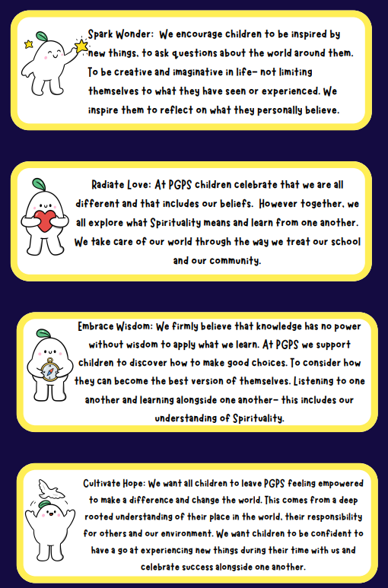

Appendix 2:


