

Marking and Feedback Policy

November 2025

A comprehensive and clear marking and feedback policy is the key to helping pupils achieve their potential. This policy aims to give guidance to staff and provide a clear outline of the expectations in regards to marking and feedback so that staff can help children embrace wisdom, spark wonder, cultivate hope and radiate love.
At Pierrepont Gamston Primary School, we believe:
- Effective learning takes place when children understand what they are trying to achieve and why. Learning objectives must focus on the learning outcome and not the activity.
- Providing children with success criteria enables them to self-assess their work, and edit and improve it, prior to it being marked. It also helps the teacher to identify a next step in learning where appropriate.
- Questioning is used to assess children’s understanding and extend their learning. This may be done verbally, during a lesson, or as a marking challenge to demonstrate the child’s independent understanding.
- Any form of feedback, written or verbal, can have an emotional impact on a child. Therefore, feedback should always be used to increase motivation and improve learning over time.
- Peer and self-assessment opportunities enable children to feel involved in identifying their achievements and next steps. It enables children to reflect on, and evaluate, their own and others’ learning.
- Our teachers can be trusted to use their judgement to know what is best for their children e.g. providing oral or written feedback, setting additional challenges or next steps, accepting the work of a child who has tried their best even though it may not be in line with age related expectations.
Legal framework
This policy has due regard to legislation and statutory guidance, including, but not limited to, the following:
- DfE (2021) Teachers’ Standards
- DfE (2013) ‘The national curriculum in England: Key stages 1 and 2 framework document’
- DfE (2015) ‘Special educational needs and disability code of practice: 0 to 25 years’
The policy is implemented in conjunction with the following school policies:
- Remote Education Policy
- Primary Curriculum Policy
- Special Educational Needs and Disabilities (SEND) Policy
Roles and responsibilities
The assessment lead is responsible for:
- Ensuring that this policy is implemented, monitored and remains effective.
- Assessing whether marking and feedback practices effectively balance the need to mark and provide feedback and the strain on teachers’ workload.
- Reviewing this policy as and when necessary to establish whether practices are effective and consistent across all subjects within the school.
Every subject leader is responsible for:
- Ensuring all members of staff are aware of the school’s procedures in terms of marking and providing feedback in their subject.
- Monitoring the effectiveness of this policy within their subject and reporting their findings back to the headteacher.
- Answering any queries that teaching staff have in regards to this policy and the school’s practices.
Teaching staff are responsible for:
- Ensuring that they adopt this policy when marking and providing feedback.
- Using their professional judgement to determine when it is appropriate to offer more intervention support systems than just feedback.
- Monitoring the learning of all pupils within their class to ensure they are making satisfactory progress.
- Ensuring that pupils understand the feedback they have been given.
- Allowing pupils to ask questions in regard to any feedback they have received.
Expectations
Teaching staff are expected to:
- Provide marking that offers clear information about why pupils have done well.
- Offer detailed suggestions and targets for improvement, which should create a progressive plan for continued learning.
- Judge whether written or verbal feedback should be given and instruct pupils to record this feedback in their books for review, as appropriate.
- Provide high quality instruction, including the use of formative assessment strategies, before providing feedback.
- Judge whether more immediate or delayed feedback is required, considering the characteristics of the task set, the individual pupil, and the collective understanding of the class, in order to provide appropriately timed feedback.
- Provide feedback that focuses on moving learning forward and that targets the specific learning gaps that pupils exhibit.
- Carefully consider how to use purposeful, time-efficient written feedback that follows high quality foundations, is appropriately timed, focuses on the task, subject, and/or self-regulation, and is then used by the pupil.
- Carefully consider how to use purposeful verbal feedback.
- Provide pupils with opportunities to reflect on feedback, which also allows them to respond to the feedback and ask questions.
- Remind pupils of their targets and how these targets can be achieved in particular lessons.
- Implement strategies that encourage pupils to welcome feedback.
- Ensure that marking identifies misconceptions and feedback addresses these swiftly.
- Use marking and assessment to identify the next steps for pupils, which should be used to plan the delivery of the curriculum.
- Offer questions and challenge pupils whose work was correct, which should encourage further development.
- Provide feedback and support to pupils with SEND and adapt how feedback is given, so that pupils with SEND can understand and action any targets.
- Provide positive and pupil-friendly marking and feedback.
- Return work promptly and allow pupils time to review any feedback that has been given to them.
Pupils are expected to:
- Try their best with any work they complete, including homework.
- Ask questions when they do not understand something in lessons.
- Read any comments on their work and ask questions if they do not understand them.
- Review their own progress by rereading previous work and establishing where they have made mistakes or identifying ways it could be improved.
- Make a conscious effort to meet their targets and to action any suggested improvements.
- Take responsibility for their learning.
- When appropriate, peer assess accurately and fairly.

Workload
The school understands that marking and providing feedback is a large contributor to the workload of teachers; therefore, teachers will ensure that their marking and feedback is only done to positively impact upon the progress of a pupil.
Teachers will ask themselves the following questions:
- Why am I providing this feedback?
- How will this feedback be useful to the pupil?
If the answers to these questions do not reflect a positive impact on pupils’ learning, teachers will use their professional judgement and decide whether the feedback is necessary.
If a teacher has a query, the respective subject leader will be available to offer guidance and support regarding the school’s procedures.
If a teacher is unsure about the effectiveness of their own practices, the assessment leader will help with developing an approach to marking and feedback that is more suited to the teacher.
Marking
All teachers will keep in mind a core set of goals when marking. The best outcomes can be achieved by focussing on the following points:
- The individual pupil’s abilities and goals
- The areas a pupil can improve in
- Giving clear guidelines for improvement
- Linking areas of improvement
- Reminding the pupil of previous success to boost confidence
- Providing effective communication between pupils and teachers
- Improving the self-belief and confidence of pupils
- Celebrating success
- Identifying pupils who require additional assistance
- Clarity and consistency of marking across the school
- The individual pupil’s level of understanding

Distance marking (marking carried out away from the classroom) will be used, to allow teachers more time to give detailed feedback.
When distance marking, there are a number of questions teachers will keep in mind, including the following:
- Are the comments easy for the pupils to understand?
- If parts of the work need improvement, are the comments constructive?
- Do comments highlight particular points for improvement?
- Have positive comments been highlighted?
- Is the pupil likely to understand why the work is correct or incorrect?
- Are the comments detailed enough to provide adequate feedback without being too long for the pupil to understand?
Pupils will be given ample time to reflect on their feedback in purple pen and will be asked to respond, if appropriate.
Teachers will allow pupils to reflect on feedback at the start of lessons, so that the feedback is at the forefront of pupils’ minds when they begin the lesson.
Positive reinforcement will be used to emphasise that pupils are improving, which will encourage them to improve their performance over time.
Rewards will be given to pupils in the following ways:
- Dojo points
- Individual class rewards
- Praise in front of whole class
- Displaying excellent work around the classroom
- Messages to parents
- Verbal praise in a one-to-one setting
Teachers will assess whether pupils understand their feedback by marking their responses where appropriate.
Teachers will encourage pupils to mark each other’s work, as this will aid pupils to identify successful methods of learning. In addition, this exercise will allow teachers to see which pupils can spot successful methods.
Peer-on-peer feedback will only be done at the teacher’s discretion and only with pupils who are expected to learn from the exercise.
Marking in maths
As maths tends to have either a correct or an incorrect answer, teachers will pay particular attention to the tone in which they mark, as pupils who struggle with this subject can become disheartened and disinterested in the subject.
Teachers will use the following techniques when marking in maths:
- Maths work will be formally marked at least twice a week, with at least one of these showing an area for development or a challenge.
- Ticking correct answers and leaving a dot next to incorrect answers
- When possible, providing immediate feedback to pupils to show them how to reach correct answers
- If the pupil has shown correct working and a wrong answer, circle the correct part and encourage them to try again
- If a pupil is excelling at a particular task, provide them with work that is more difficult so that they continue to feel challenged
Marking in English writing
Marking independent English writing can differ from other subjects as often answers are subjective and have to be supported by evidence. When marking in English writing, teachers will use the following techniques:
- Give feedback on whether the learning objective has been achieved and the success criteria followed
- Identify the next steps in the learning process
- Explain how the work can be improved by making sure the advice is age appropriate and linked to the objectives of the year group
- Correct spellings, particularly those appropriate for the year group
- Correct punctuation and grammatical errors appropriate to the objectives for the year group
- Allow specific time for pupils to read, reflect, and respond to marking
- Children’s written work will be formally marked at least twice a week, with at least one of these showing an area for development or a challenge.
- Mark using a green pen.
- Marking must avoid highlighting specific errors to allow independent correction by the child.
Marking in Science and Foundation Subjects:
Marking of science and foundation subjects varies from subject to subject.
- Science, geography, history and RE will be marked at least twice per half term with an indication of what the child has done well and either an area for development or a challenge.
- Spanish will be marked at least once per half term with an indication of what the child has done well and either an area for development or a challenge.
- PE, art, computing, PSHE, music and design and technology work, by the nature of their learning, require a larger degree of verbal feedback. Evidence of these units will be collected where relevant (for example through photos or within a class computing evidence folder) but there is no expectation of staff to provide written feedback.

Feedback
Feedback should be given to:
- Motivate pupils.
- Address misunderstandings.
- Establish an opportunity to make learning progress, by:
  - Rectifying a misunderstanding.
  - Reinforcing a skill or piece of information.
  - Improving on a pupil’s understanding or ability to do something.
Feedback differs from marking in that it is not limited to comments placed on the work of pupils; for example, feedback can be immediate verbal communication in the classroom or provided during one-to-one meetings.
To avoid unnecessary confusion and to ensure clear progression in lessons, teachers will ensure that lessons remain focussed by:
- Clearly outlining which subject content will be covered in each class.
- Explaining the areas pupils will need to understand.
- Having a clear plan in mind for the progression of learning in the subject.
- Having a final goal in mind for the month/term/year.
- Having a number of progression plans that account for all abilities in the class.
- Making it clear what the objectives are from week to week, as well as final expectations.
The school believes in developing independent thinkers and as such, feedback will guide the pupil to the correct answers, as opposed to giving the answers away.
Teachers will use one of the following three methods to suggest improvements when offering feedback:
- Reminder: Instead of marking an answer as incorrect, attempt to guide the pupil to the correct area. This will be done by reminding them of a recent success that is linked to the question they are currently struggling with.
- Scaffold: By asking the pupil a question, teachers can guide them to the correct answer. An example of this may be: “Are you trying to achieve A, B or C?” By doing this, teachers guide the pupil to looking at these three areas. Pupils should then find the correct answer and also feel like they achieved it themselves.
- Example: By giving examples of possible changes to the pupil, teachers can guide them into exploring why they should choose one option over another. An example of this may be if a pupil were writing a story in class and was struggling to find the correct word to use, the teacher could give three examples of possible words and leave the pupil to choose.
Verbal feedback can act as a way to give immediate and effective feedback to pupils.
Teachers will mark on pupils’ work when verbal feedback was given.
Teachers will keep in mind the following considerations when giving verbal feedback:
- Tone of voice: It is important to remain as calm as possible. If the teacher displays signs of frustration, the pupil may feel under pressure and fail to perform to their full potential.
- Balancing time: If a particular pupil requires more time and attention, the teacher may consider giving feedback in written form or in a one-to-one meeting.
- Class discussions: Involving the whole class in discussions can be useful when introducing new subjects to the class. By asking questions to the whole class, the teacher can get a good idea of the general level of the class and plan future lessons and feedback accordingly.
When giving feedback, teachers will consider any SEND the pupils have, and will make adjustments to the way feedback is given and the targets that are set to suit their individual needs in line with the SEND Policy.
Appendices:
- Marking code for EYFS and KS1
- KS2 English Marking Guidance
- KS2 Maths Marking Guidance
Date: 19th November 2025 Review date: November 2026
Marking Codes for FS and KS1
When marking in EYFS or KS1, please use the following marking codes to explain what children have done well and what they could do to improve their learning.
 | Correct
 | What you have done well
→ | Corrections
 | Independent next step to improve own work
 | Start writing left to right
abc | Form your letters carefully
 | Finger spaces
. | Full stop as small as a dot
 | Joining word
Sp | Spelling
A | Capital letters

Please also note, if children’s learning was completed with or without support this may be indicated on the work or WALT:
G | Adult guided
S | Supported
I | Independent learning

Key Stage 2 English Marking Guidance
enabling
Long Date
Underlined with a ruler.
(Short or scribed for SEND)
S

I

KS2 Marking Codes:
- Punctuation error
SC or target met
Missing word
// Paragraph needed
S Spelling mistake
G Grammar mistake
Re-check this sentence
(with comment)
R Repeated word
V Poor vocabulary


1st September 2015
Assessment for Learning (AFL) is concerned with both the pupil and the teacher being aware of where learners are in their learning, where they need to go and how to get there. We believe AFL improves learning, enables progress, empowers learners and raises standards. The way we mark and give feedback to pupils is central to the whole process.

Explicit Learning Objectives
We believe that effective learning takes place when learners understand what they are trying to achieve and why.
It is therefore important that pupils know the learning objective for the lesson as this gives a focus, helping pupils to review their own progress and to see if they have achieved the stated aim.

Subheadings, aimed at adults
Technical vocabulary
Q2
Pupils , as well as staff, should use marking to inform their learning.

Teacher demonstration and modelling will closely relate to the learning objective as will the subsequent activities. Together these will support and guide children to achieve the lesson intention. The learning objectives will focus on learning not activities.
2. Success Criteria
Developing success criteria to achieve the learning objective will help provide children with a framework against which they can focus their efforts, evaluate their progress and discuss issues. We recognise that on occasions there is no need for more than one or two success criteria and at other times more, dependent on the task, age and identified needs. Feedback against the criteria frees children from personal discouragement.
One way of using success criteria to differentiate the level of challenge in a lesson is to use ‘Will, Should and Could’. The Will statements are what every response should include, whilst the Should statements are what a really good response should include. The Could statements are what a child might include if they really want to challenge themselves.
Differentiated WALT grids
Linked to national / mastery standards, with I can statements
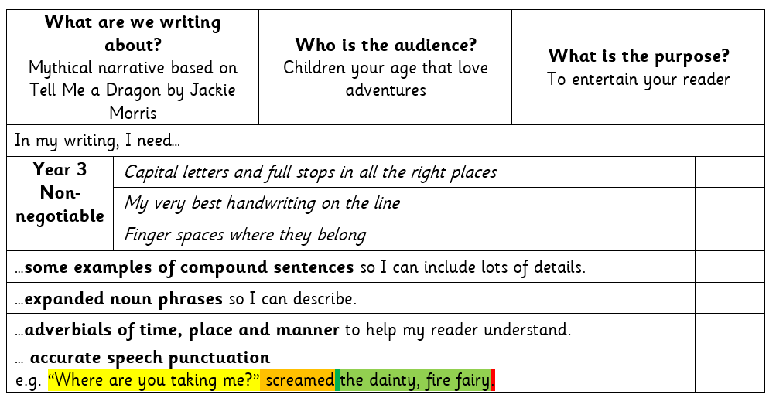

both teachers and pupils (JS)

Teacher Comments in Note Form Where Applicable:
Good points based on assessed objectives
Marking question / instruction
SPx3 Spelling corrections
Next step for subsequent work

Peer Assessment
In purple pen and initialled

Self-Assessment
In purple pen, with errors crossed out using a ruler

Child’s Response or Editing:
In purple and to be marked with subsequent work.
Key Stage 2 Maths Marking Guidance
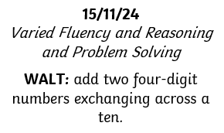

Marking Codes:
Correct
. Incorrect
Missing point or operation sign

Date
Underlined with a ruler if not on the WALT sticker.

1 4 5
+ 3 4 3
4 8 8

1 4 5 1 4 5
+ 3 6 9 + 3 6 9
4 8 8 x 5¹ 1¹ 4

Through the use of worded problems and puzzles, children should
develop their mathematical skills in a range of contexts.

+ without carrying
– or ; below
Q2
1L = 1000ml

Teacher demonstration and modelling will closely relate to the learning objective as will the subsequent activities. Together these will support and guide children to achieve the lesson intention. The learning objectives will focus on learning not activities.
2. Success Criteria
Developing success criteria to achieve the learning objective will help provide children with a framework against which they can focus their efforts, evaluate their progress and discuss issues. We recognise that on occasions there is no need for more than one or two success criteria and at other times more, dependent on the task, age and identified needs. Feedback against the criteria frees children from personal discouragement.
One way of using success criteria to differentiate the level of challenge in a lesson is to use ‘Will, Should and Could’. The Will statements are what every response should include, whilst the Should statements are what a really good response should include. The Could statements are what a child might include if they really want to challenge themselves.
Scaffolded Working in green pen
Self-Assessment
In purple, with errors crossed out using a ruler. ‘?’ denote unsure

Development Question:
Written instruction at the start of the next lesson (eg Q1, Q2 or Q3)

Child’s Response:
To be marked with subsequent work

Teacher Comments in Note Form:
= positive points
= areas for development
(may be next to q’s rather than at the end)

Margin and Question numbers
No circles around numbers.
(Missed or scribed for SEND)

investigations
1.

2.

3.

01.09.25

