Welcome to Pierrepont Gamston Primary School

Parents Welcome Information
September 2026

Dear Parents,

We are looking forward to welcoming you and your child to Pierrepont Gamston Primary School in the coming weeks.

We want this to be the beginning of a happy and successful time for your child and a supportive partnership with you. However, we recognise that starting school can be an anxious time for both children and parents. The aim of this booklet is to provide you with practical information and some useful advice to help make your child’s transition into the Reception Class as smooth as possible.

If you have any questions or concerns, please do not hesitate to contact us.
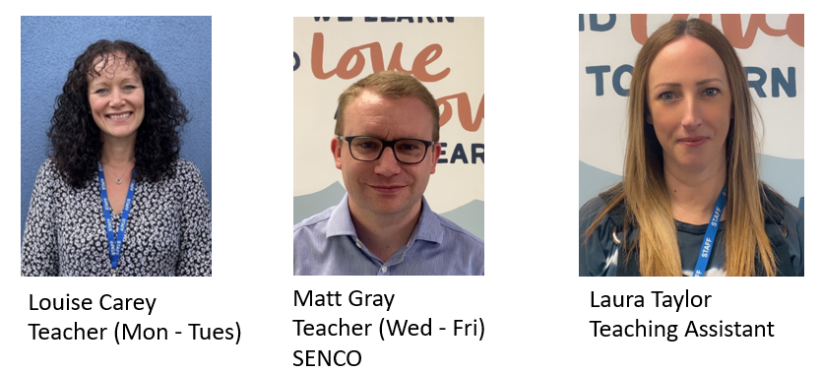

Starting school
Resources to help prepare your child for school are available on our New Starters September 2025 page in the class section of the school website at https://www.pgps.org.uk/page/?title=New+Starters+September+2026&pid=62



Starting in September

- First & Second Day in School: Thursday 3rd September and Friday 4th September from 9.00am-12pm

- Lunch stays: Monday 7th September 8.45am-1.30pm

- Full time: Tuesday 8th September children will start full time education 8.45am-3.25pm (pick up from 3.15pm)

Learning Together

Being a parent is one of the most rewarding jobs in the world. We believe that you are your child’s first and most important educators.

Learning before school
By this time of year, many children are ready to begin school. They may already have experienced Pre-School education and will have learned many skills and will understand a great deal.
During their first years of life your child has already learned skills that will help them to make a flying start at school:
- Feeling good about themselves
- Listening carefully
- Talking about their thoughts and feelings
- Knowing many stories, songs and rhymes
- Knowing what their own name looks like
- Recognising and knowing about letters and numbers
- Knowing about the different reasons for writing
- Wanting to learn

All these things continue to be important at school, especially the ‘wanting to learn’.

When your child starts school, the support you give them and continue to give them over the years will have an enormous influence on their achievements.
Here are some of the things that will make a real difference right from the start:
- Lots of songs and rhymes
- Listening games
- Playing with shapes
- Drawing and colouring
- Sharing a book everyday- perhaps the most important.

Useful Skills
When your child starts school it would be helpful if he/she could do these things:
Use a knife and fork
Dress and undress
independently

in
Take off coat Put on coat and Change shoes
and hang it up fasten it

Help to tidy toys away
Use the toilet Wash and dry Share toys and take turns
properly and flush it hands

PE Lessons

The children will have one P.E. session per week. This may occur at different points during the week, so it is vital that your child has their full P.E. kit in school each day of the week. It can be left on their peg during the week and we will make sure it returns home at the end of each half term for a good wash!

P.E. Kit includes:
- Black shorts
- Plain t-shirt (until sorted into houses in October, after which they will wear their house colour)
- Trainers (not until the summer term)
- Socks

Please ensure that all items are named – it helps enormously when getting changed!

Please be aware that jewellery is not allowed to be worn in school and cannot be worn during P.E. lessons under any circumstances.

A typical school day in Reception Class

8.45am Teachers will meet the children at the gate and they will enter the classroom by themselves. Children hang their coats independently and take any necessary letters out of their bags. We ask parents to stay outside the gates and pass on any urgent messages to a member of staff.

8.50am Children will sit altogether to be registered

9.00am Phonics - children will split into groups of 15 for guided carpet session

9.15am Independent learning activities – choosing activities from our continuous provision or attempting learning challenges

10.05am Munch and Mingle (story time with fruit and milk)

10.20am Break time - children will spend time on the whole school playground so that they can see older siblings or friends.

10.35am Children will split into groups of 15 for guided carpet session (e.g. English, maths or topic)

10.50am Independent learning activities

11.35am Toilet and wash hands ready for lunch.

11.45am Lunchtime

12.45pm Children will sit altogether to be registered

12.55pm Children will split into groups of 15 for guided carpet session (e.g. English, maths or topic)

1.10pm Independent learning activities

1.45pm Worship with whole school.

2.05pm Children will split into groups of 15 for guided carpet session (e.g. English, maths or topic)

2.20pm Independent learning activities

3.00pm Prepare to go home

3.15- 3.25pm Children share a story/song with one adult whilst the other two adults ensure that children are returned safely to the adult collecting them. The gates will be open from 3.15pm so that handover can be staggered - please collect your child within the specified 10 minute window.

